COUNCIL ASSESSMENT REPORT

Panel Reference | PPSSEC-55
DA Number | DA/259/2020
LGA | Randwick City Council
Proposed Development | Demolition of existing school buildings, internal playground area and the construction of a new administration block, pedestrian entry, new amenities, playground area and landscaping
Street Address | 268-280 Fitzgerald Avenue Maroubra NSW 2035
Applicant/Owner | Sydney Catholic Schools
Date of DA lodgement | 10 June 2020
Number of Submissions | One (1)
Recommendation | Approval - subject to conditions of consent
Regional Development Criteria (Schedule 7 of the SEPP (State and Regional Development) 2011 | Private Infrastructure and community facilities over $5million – an Educational Establishment with capital investment value of $9,870,000.
List of all relevant s4.15(1)(a) matters | - State Environmental Planning Policy educational establishment and childcare facilities 2017  - State Environmental Planning Policy (State and Regional Development) 2011  - State Environmental Planning Policy No. 55 – Remediation of Land  - Randwick Local Environmental Plan 2013  - Randwick Comprehensive Development Control Plan 2012
List all documents submitted with this report for the Panel’s consideration | - Development Application Assessment Report  - Architectural documentation - Plans, Elevations, Sections and 3D images/photomontages  - Traffic Report  - Waste Management Plan  - Access Report  - Acoustic Report  - Arborist Report  - BCA Assessment  - Contamination Report  - Geotechnical Report  - Revised Flood Risk Report  - Survey Plan  - Statement of Environmental Effects
Clause 4.6 requests | No Clause 4.6 Variations are proposed.
Summary of key submissions | - Traffic and parking concerns  - Bulk and scale, including visual impact and streetscape presentation  - Amenity concerns in relation to overshadowing, privacy, visual amenity
Report prepared by | Mitchell Drake Senior Development Assessment Officer
Report date | 30 April 2021

Summary of s4.15 matters  Have all recommendations in relation to relevant s4.15 matters been summarised in the Executive Summary of the assessment report? | Yes
Legislative clauses requiring consent authority satisfaction  Have relevant clauses in all applicable environmental planning instruments where the consent authority must be satisfied about a particular matter been listed, and relevant recommendations summarized, in the Executive Summary of the assessment report?  e.g. Clause 7 of SEPP 55 - Remediation of Land, Clause 4.6(4) of the relevant LEP | Yes
Clause 4.6 Exceptions to development standards  If a written request for a contravention to a development standard (clause 4.6 of the LEP) has been received, has it been attached to the assessment report? | Not Applicable
Special Infrastructure Contributions  Does the DA require Special Infrastructure Contributions conditions (S7.24)?  Note: Certain DAs in the Western Sydney Growth Areas Special Contributions Area may require specific Special Infrastructure Contributions (SIC) conditions | Not Applicable
Conditions  Have draft conditions been provided to the applicant for comment?  Note: in order to reduce delays in determinations, the Panel prefer that draft conditions, notwithstanding Council’s recommendation, be provided to the applicant to enable any comments to be considered as part of the assessment report | No

Sydney Eastern Planning Panel

SEPP No. | PPSSEC-55
DA No: | DA/259/2020, 268-280 Fitzgerald Avenue, Maroubra , Demolition of existing Building A, B, C and existing Internal playground area.; removing of existing demountable building; refurbishment of building D and E (including Aspect classrooms); Construction of a new administration block, pedestrian entry, new amenities, playground area and landscaping.
Applicant: | Sydney Catholic Schools
Report By: | Mitchell Drake Senior Development Assessment Officer

1.0 Executive Summary

Council is in receipt of a development application seeking consent for the redevelopment of the existing St Mary St Joseph School, including demolition of the existing Blocks A, B and C, basketball court and soccer field and the removal of demountable classroom (Aspect). Site Excavation and preparation works to be followed by construction of a two-storey building containing a new staff room, administration area, general learning areas (GLAs) x 6, library and amenities. Further works include the internal refurbishment of existing Blocks D and E to include 8 x GLAs, amenities, art room and new Aspect facility, together with a new basketball court, playground and ancillary works accommodating the remainder of the proposal.
Pursuant to Section 4.7, of the Environmental Planning and Assessment Act 1979 and schedule 7 of the State Environmental Planning Policy (State and Regional Development) 2011, as the development is an Educational Establishment with a capital investment value in excess of $5 million, the development is defined as Regionally Significant Development, and the application is referred to Sydney Eastern City Planning Panel for determination.

The subject application was advertised and notified from 17 June 2020 through to 1 July 2020 and one (1) submission was received as a result of the notification process. Issues raised included; amenity concerns in relation to overshadowing, privacy and visual amenity. These items are addressed within the responses to the objections and are not determining factors in the approval of the application. Each of these elements has been found to be satisfactorily responded to by the proposal

The subject site currently comprises the St Mary St Joseph School and is located at 268-274 Fitzpatrick Avenue, Maroubra. The site is bounded by Mons Avenue to the North, Fitzgerald Avenue to the south and Malabar Road to the west and has a total site area of 8612m².

The subject site is zoned SP2 – Educational Establishment under Randwick Local Environmental Plan 2012 (RLEP 2012). The proposal is consistent with the zoning objectives Due to the SP2 zoning and nature of the development, being an Educational Establishment, there are no applicable development standards for the subject site, notwithstanding the proposed development is considered to be consistent with the objectives of the height and FSR standards.

As the proposal is for alterations and additions to a school, the provisions of State Environmental Planning Policy (Educational Establishments and Child Care Facilities) 2017 apply. The proposal is considered to satisfy the design quality principles set out in Schedule 4 of the SEPP and the relevant clauses pursuant to Part 4 of the SEPP.

The site is constrained to a minor degree by an existing overland flow path which is the subject of flood modelling. Councils Development Engineers have indicated that for all intents and purposes the proposed wall which is ancillary to the development on Fitzgerald Avenue will cause no variation in flood behaviour during the 1% AEP (1 in 100yr) flood. In the PMF event, flooding from Malabar Rd and the SE corner no longer occurs due to the flood wall.

With respect to the amenity impacts, the proposed development will not contribute to any unreasonable overshadowing, noting that compliant solar access is provided in accordance with the Randwick complrehensive DCP, for both the subject site and its open areas and internals, and the existing developments surrounding the development on opposite sides of the roadways . Due to the spatial separation between the subject site and adjoining residential properties, the proposed development is not considered to result in any unreasonable visual privacy impacts, with the main recreation areas orientated to the interior of the site. Furthermore, assessment by Council’s Environmental Health Officer concludes that there shall be no significant increase to noise impacts as a result of the proposed development.

The proposal satisfies the matters for consideration under Section 4.15 of the Environmental Planning and Assessment Act 1979 and is recommended for approval subject to the recommended conditions.

- Site Description and Locality

The site is legally known as the three (3) following identifiers:
- Lot 4370 in DP 752015 – commonly known as 268-272 Fitzgerald Avenue
- Lot 4916 in DP 752015 – commonly known as 274-280 Fitzgerald Avenue
- Lot 1 in DP 121298 – commonly known as 274-280 Fitzgerald Avenue

The allotments are within the SP2 Educational Establishment Zone:

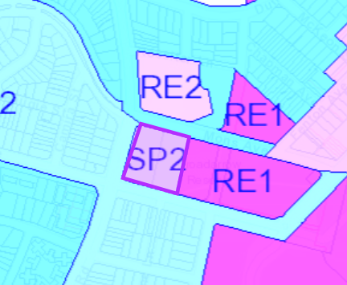

Figure 1: Zone Map

The site is regular in shape with three (3) separate frontages to Mons Avenue to the North, Fitzgerald Avenue to the south and Malabar Road to the west. The east is bounded by open space. The overall site area is 8612m². The site is occupied by three (3) single storey brick buildings, covered outdoor learning area (COLA), games courts, Parish and demountable building. The permanent buildings are described as follows:
- Block A
- Block B
- Block C
- Block D
- Block E
- Block F: Hall and COLA
- Parish – Currently leased to community group
- Demountable Classroom (Aspect)

The existing permanent buildings are located on the southern portion of the site with play areas and sports fields located to the north west. A small playground with sunshade is also located between Block B and Block D. An overview of the site is provided at Figure 2 below:

Topographically, there are no significant features save the trees on the boundaries and street fronts of the school on all boundaries (Refer Figure 3 and 4). Pedestrian and vehicle access is gained from the northern, southern and western boundaries via existing paths and gutter crossings.

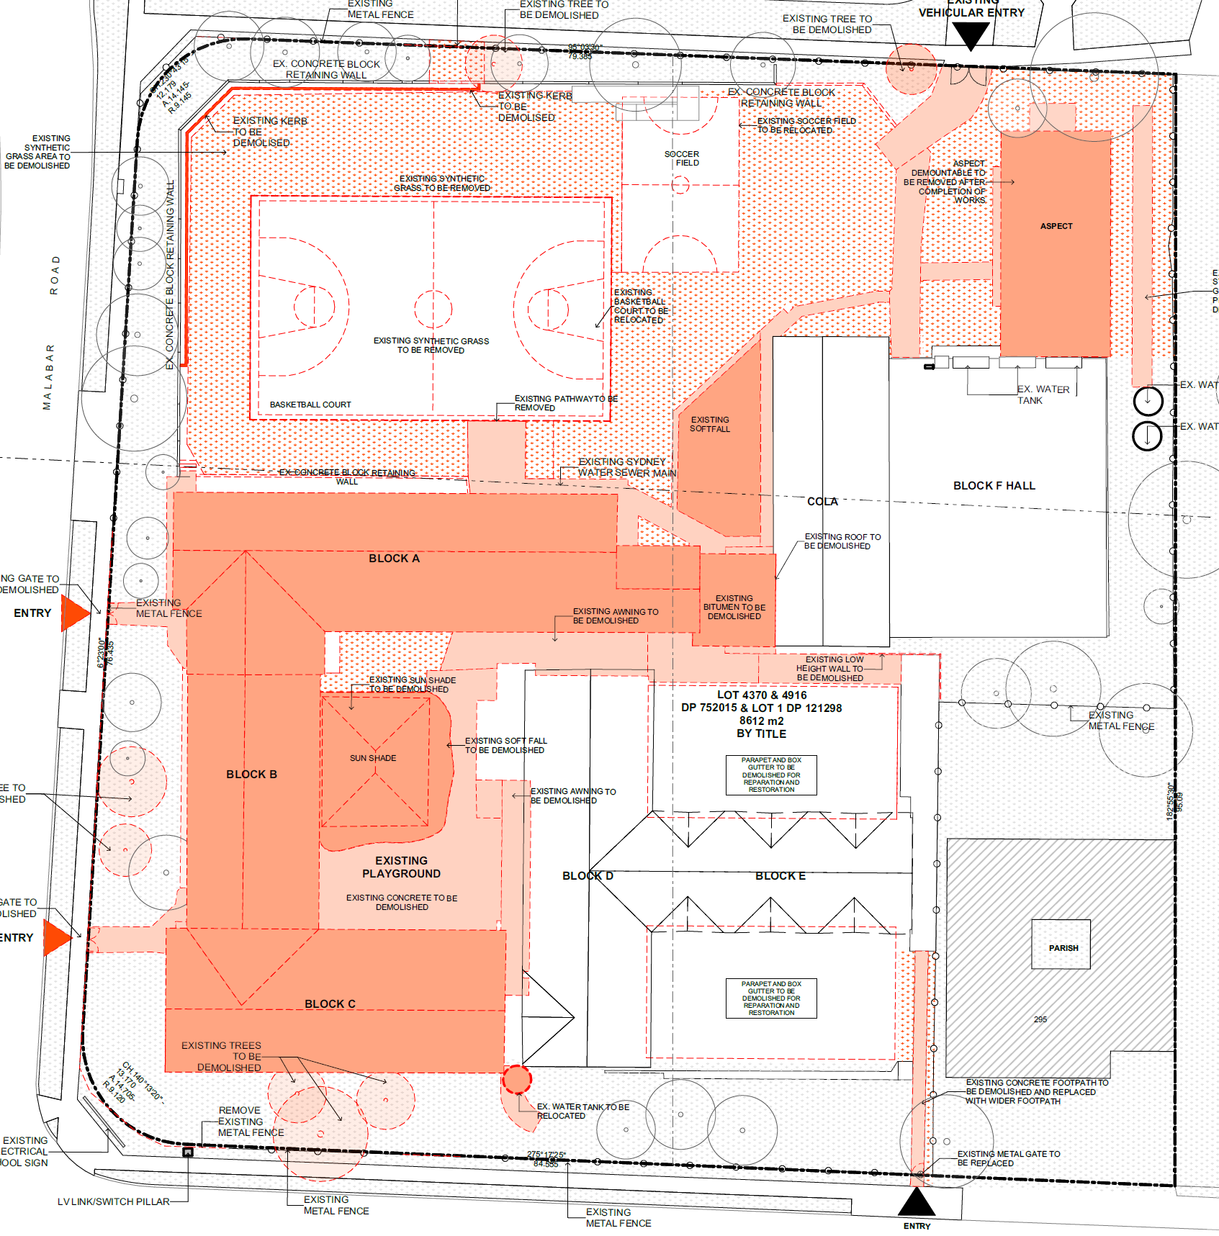
Figure 2: Site Overview Source: JDH Architects

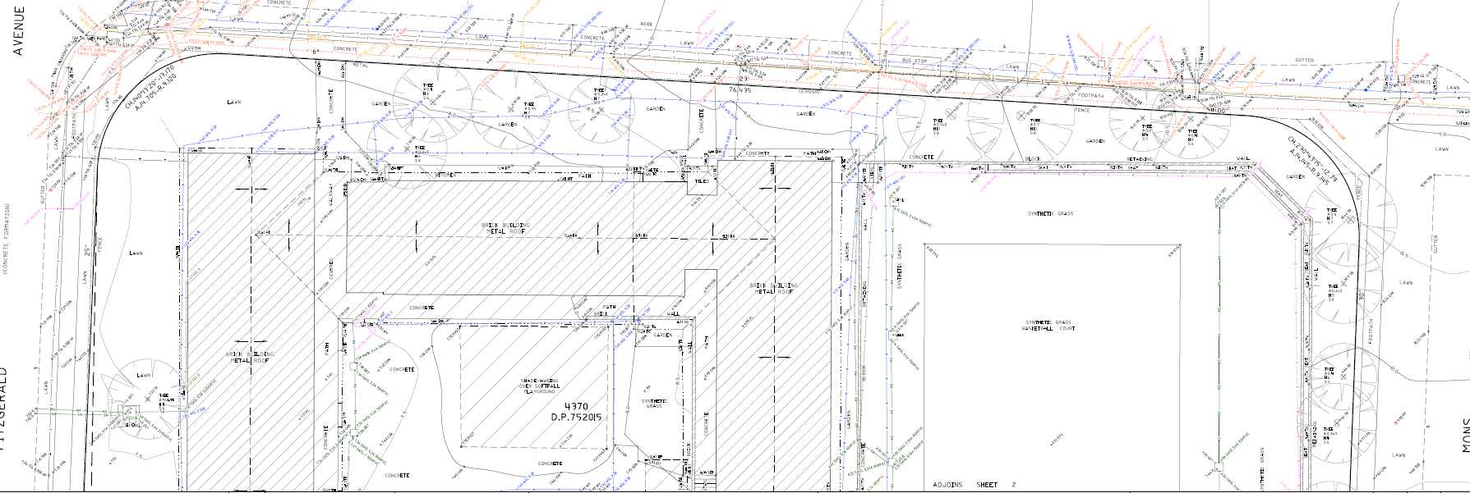
Figure 3: Northern Portion Survey Source: CMS Surveyors

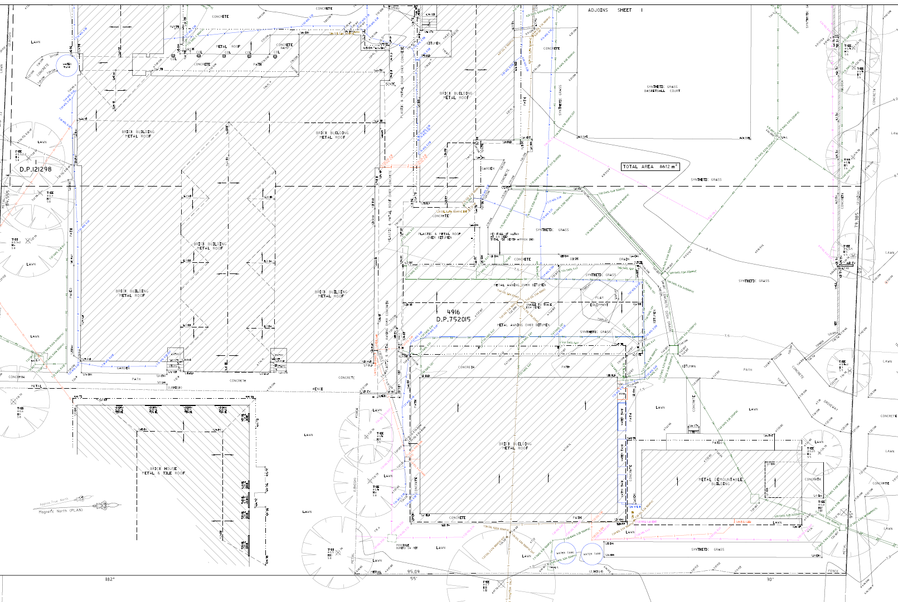
Figure 4: Southern Portion Survey Source: CMS Surveyors

- Relevant History

The following history is relevant to the subject proposal:
- The subject proposal was lodged on 10 June 2020,
- The subsequent notification was undertaken from 17 June 2020 through to 1 July 2020 and one (1) submission was received,
- Additional information was requested on 20 October 2020, with regards to comments from:
  - The Design excellence Panel,
  - Assessment Officer,
  - Landscape Officer,

- On 26 October 2020 the applicant was requested to withdraw the application due to flooding and other issues.

- On the 10 November 2020 further comments, we received from Council Engineers with regards to flooding.

- A Seven (7) day letter was forwarded to the applicant on 19 February 2021 where the applicant was again requested to withdraw the application at this point.

- On 3 March 2021, a revised set of flood control solutions including plans and data were received and forwarded to Councils Development Engineers for comment.

- On 29 April 2021 the final referral was received from Councils Development Engineers, recommending the application be approved subject to conditions.

- The Proposed Development

The applicant seeks approval for the following proposed development which is comprised of:

- Demolition of the existing Blocks A, B and C, basketball court and soccer field and removal of demountable classroom (Aspect);
- Site Excavation and preparation works;
- Construction of a two-storey building containing a new staff room, administration area, general learning areas (GLAs) x 6, library and amenities;
- Internal refurbishment of existing Blocks D and E to include 8 x GLAs, amenities, art room and new Aspect facility;
- New basketball court and playground;

The works are proposed to be undertaken in two (2) stages. The first stage will comprise the construction of a new two storey building on the existing basketball court. The building will contain administration and staff facilities on the ground floor and six (6) General Learning Areas (GLAs) on the first floor.

The two floors will be linked by a central staircase and lift with a second staircase located at the western end of the building. External pedestrian access will be via a new main entrance from Mons Avenue and within the school.

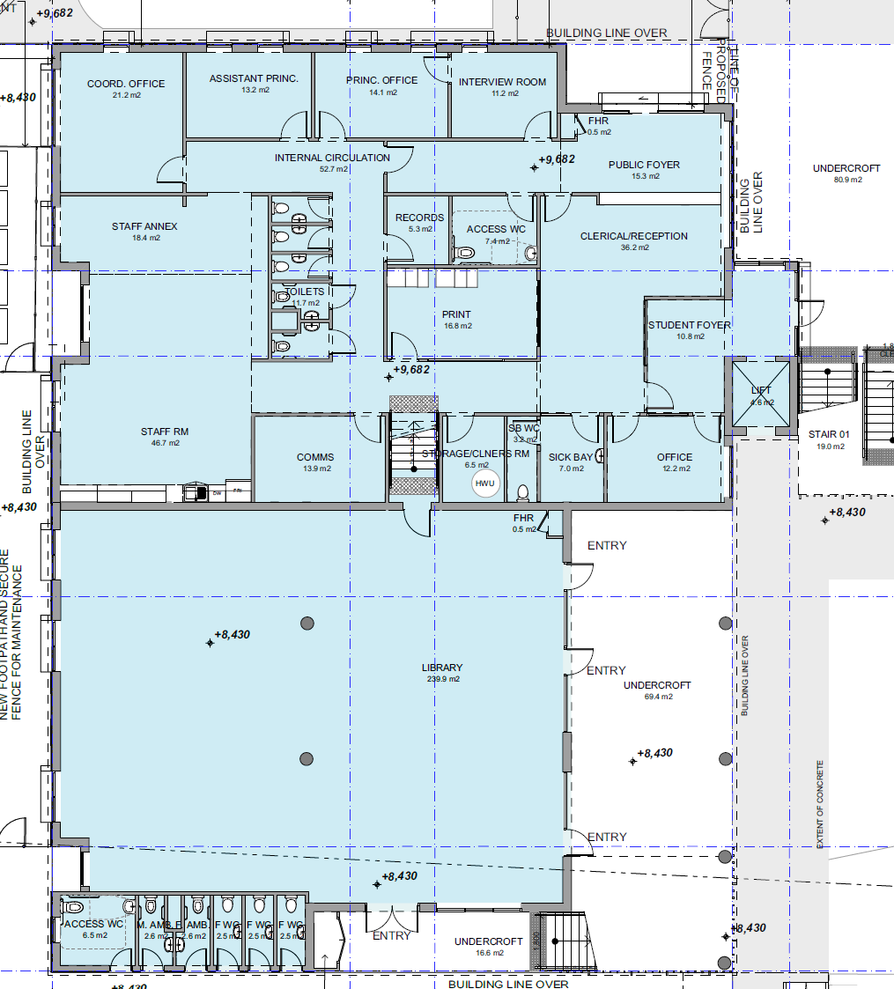
Figure 5: Ground Floor Building Stage 1 Source: JDH Architects

The two-storey building will have a Gross Floor Area of 1,442m² and contains on the Ground Floor:

  - Public foyer;
  - Canteen;
  - Offices including Principals and Assistant Principal;
  - Administration facilities;
  - A central library
  - Lift and stairs;
  - Staff room with associated amenities and deck; and
  - Sick bay and cleaner’s room.
And on the first floor,
  - Six (6) General Learning Areas;
  - Male, female and accessible amenities;
  - Three (3) wet areas;
  - Lift and stairs; and
  - Cleaner’s room.

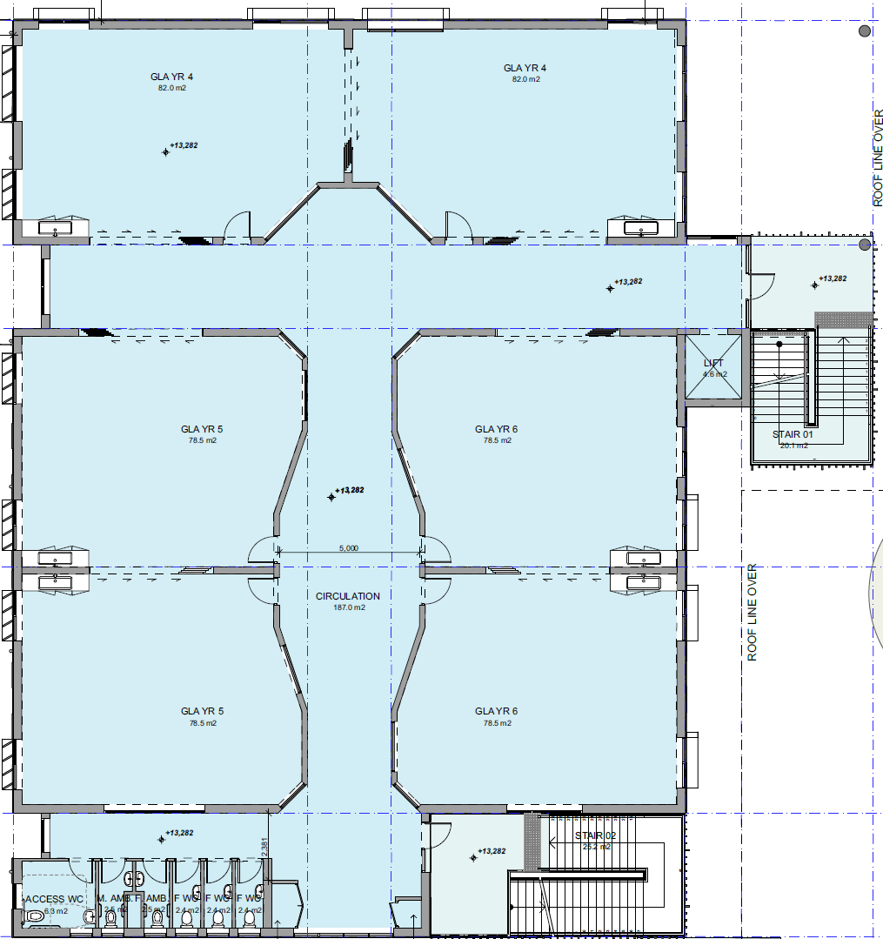
Figure 6: First Floor Building Stage 1 Source: JDH Architects

The second stage will include the following alterations to Blocks D and E incorporating:

  - Internal refurbishment to form eight (8) GLAs and
  - New awning on the northern and western elevation; and
  - Male, female and accessible amenities.

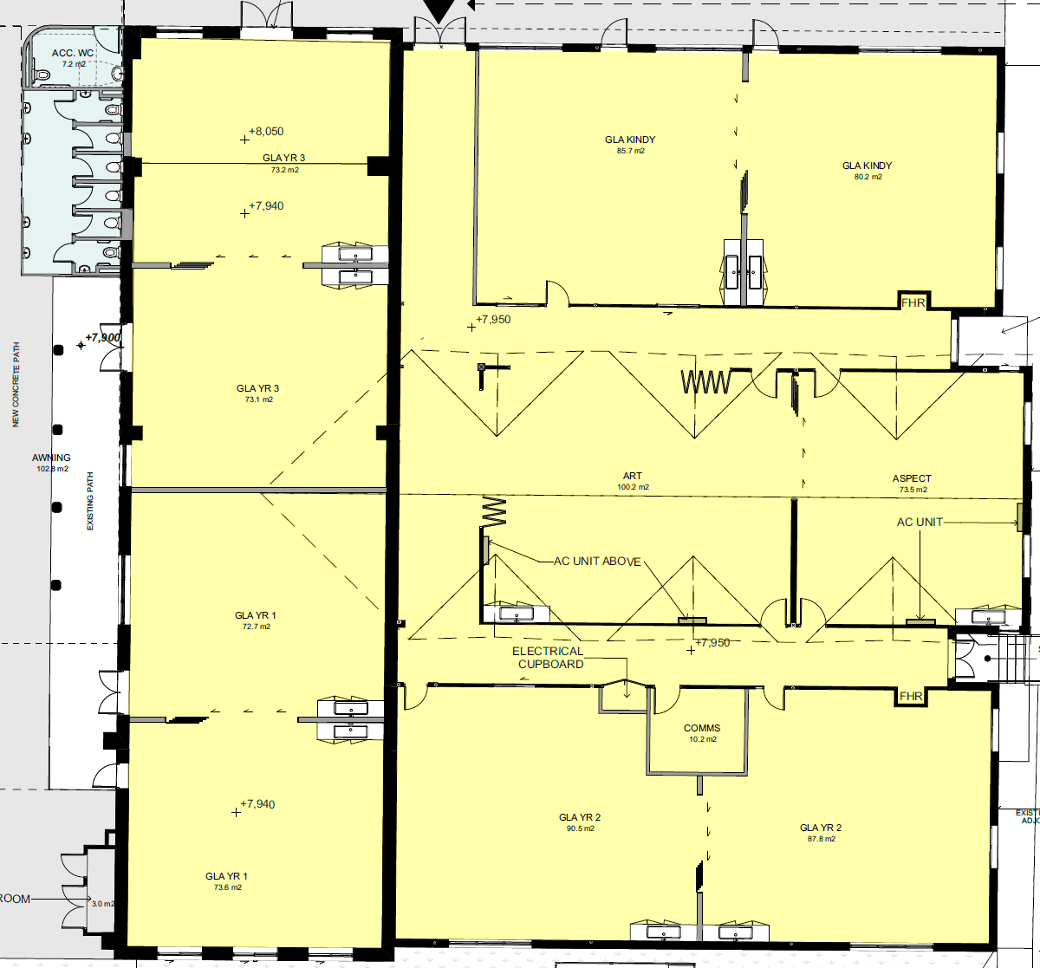
Figure 7: Ground Floor Building Stage 2 Source: JDH Architects

- Clause 4.6 Exception to Development Standard

There are no variations to development standards requested under the provisions of Clause 4.6

- Notification/ Advertising

The subject development was advertised/notified to surrounding landowners for a period of 14 days between 17 June 2020 and 1 July 2020 in accordance with Council’s DCP. As a result, one (1) submission from the following property was received.

- 291 Fitzgerald Avenue

Issues | Comments
Building Size  The submission raises concerns with regards to the size of the building and the potential impacts upon existing amenity. | The new works, when measured against the existing buildings making up the school, do not result in an unreasonable impact with regards to existing amenity. The amenity of the locale is an eclectic mix of low and medium density development with areas of public and private open spaces. The new school buildings add to the existing mix of development within this landuse nexus. The objection is not considered to carry any determining weight.
Impacts During Construction  The submission raises concerns with regards to noise, dust and other pollution during construction and the potential for damage to adjoining property. | Dust emissions, noise and other construction impacts will be apparent during the development.  In this regard, a condition of consent is recommended appropriate hours of construction, traffic management and dust suppression, together with appropriate waste disposal measures be undertaken for the development process.  The condition adequately addresses the concerns raised within the submission.
Contrary to Character  The submission raises concerns with the development being “out of character” with the quiet low-rise residential area. | The existing school, whilst of a different built form to the dwellings within the surrounds, serves the community in an appropriate location. Further, the school is able to facilitate development that will not adversely affect the amenity of nearby and adjoining development, consistent with the objectives.  It is also noted that the school is located at the nexus of various zones being:  - RE1 – Public Recreation  - RE2 – Private Recreation  - R2 – Low Density Residential  - R3 – Medium Density Residential  The school is the appropriate development type to be able to create an appropriate nexus at this junction of various zone typologies.  The proposal is not out of character and the objection is not considered to carry any determining weight.
Accuracy of the Traffic Management Plan  The submission raises concerns with regards to the Traffic Management Plan and its accuracy in terms of increased children numbers. | Councils traffic management section have reviewed the Traffic Management Plan (TMP) and find the data to be accurate and sufficient to support the proposal.  The TMP is recommended to be incorporated into condition of consent. The SEE submitted with the development application indicates current number of students at 328 and staff numbers at 29. The SEE further advised that these numbers will not change. A condition is also recommended to cap the school population at the current number.  The objection is not considered to carry any determining weight in this regard.
Consideration of Surrounding Developments  The submission raises concerns with regards to the impacts of the proposal when combined with other surrounding developments, particularly the nearby former Bowling Club. | During assessment, consideration is given to current applications approved in addition to the existing built form and landuse patterns at the time of the development proposal. This includes the Land and Environment Court proceedings relating to DA/631/2018 for demolition of existing structures and tree removal, construction of a seniors housing development comprising a 4 storey residential care facility accommodating 108 beds and a 1 x 3 storey and 2 x 4 storey  buildings containing 38 and 25a total of 56 independent living units respectively, basement  car parking accommodating 100 97 vehicles, ancillary services in a community hub comprising a chapel, café, swimming pool and multi-purpose space, and associated landscaping works and a through-site pedestrian link.  This development was granted consent via the Land and Environment Court in which all aspects of the proposal were reviewed.  As the proposal is active, cognizance was taken of this approval and, in considering the subject application, it is evident that the works will not have an unreasonable impact on the community or the surrounds in its operation near to the aged housing scheme subject to DA/631/2018.  The works to the school have been measured against the impacts of the remaining existing and proposed development and found to be appropriate. The objection carries no determining weight.
Ownership of properties  The submission raises concerns with the ownership of subject property and the former bowling club property being by the same owner, thus biasing the community comments and responses. | The proposal has been notified in accordance with Councils Community participation plan and the associated Act and Regulations. In addition, a rigorous assessment of the proposal has been undertaken which will be further review by the independent regional panel.  Any bias within the community with regards to submissions will be addressed by these process.
Solar Access  The submission raises concerns with regards to overshadowing during the winter solstice (21st June). | The proposed new two storey building is located towards the north western corner any additional overshadowing will be within the school premises. A review of the landscaping indicates appropriate vegetation selection for adequate sunlight to adjoining properties The objection is not considered to carry any determining weight
Landscaping Concerns  The submission raises concerns with regards to the landscaping design cause further overshadowing. | A review of the landscaping indicates appropriate vegetation selection for adequate sunlight to adjoining properties.  The objection is considered to carry no determining weight.
Privacy Impacts  The submission raises concerns with regards to privacy impacts from a new two (2) storey building. | Due to site separation and site orientation, the privacy of adjoining dwellings on opposite sides of the roadways surrounding the school will be maintained to a reasonable level in this well established residential/educational nexus.
Future constraints of development  The submission raises concerns with regards to the school objecting to future plans for the dwelling impacting on the school’s privacy and thus preventing development. | The proposal is assessed with the current plans and policies of Council together with state government controls. This includes the potential for constraining of the adjoining and nearby sites for potential future development.  These considerations have been undertaken during the assessment of the school proposal and it is considered that, with thoughtful and appropriate development designs, that no sites are constrained or isolated as a result of the proposal.  The objection carries no determining weight.

- Technical Advice: Internal and External

  - Development Engineer and Landscape Officer

The application was referred in the first instance on 11 June 2020 and the following comments were received:

An application has been received for the demolition of existing Building A, B, C at St Mary St Joseph catholic School and existing Internal playground area.; removing of existing demountable building; refurbishment of building D and E (including Aspect classrooms); Construction of a new administration block, pedestrian entry, new amenities, playground area and landscaping. at the above site.

This report is based on the following plans and documentation:
- Architectural Plans by JDH Architects dated 2020;
- Statement of Environmental Effects
- Detail & Level Survey by CMS Surveyors Pty Ltd dated 15-08/2019
- Flood Impact Assessment by Cohort Engineering dated 15th May 2020

GENERAL COMMENTS
The assessing officer is advised that application is not supported due to identified flooding issues. The issues are outlined in detail below.

FLOODING ISSUES
Part B8 of Council’s DCP states that schools are classified as a “critical facility” and accordingly in Table A specifies that floor levels must be provided as per the following;

Habitable Floor – (Critical Facility)

- Inundated by flooding – PMF + 0.5m freeboard

Application of the above requirements would require the ground floor of the new staff, admin and GLA building on the western side of the site to be no lower than RL 9.44 AHD (8.93 + 0.5). The submitted plans indicate the new admin building with a floor level of RL 9.682 and so complies with this requirement, however the floor level of the adjacent library is depicted as only RL 8.43 AHD being well below the flood planning level derived from the Council flood report.

The non-compliance has not been acknowledged in the Statement of Environmental Effect or accompanying Flood risk management Plan Report by Cohort Engineering and is not supported by Development Engineering. The floor level of the library will therefore need to be raised to a minimum RL of 9.43 AHD.

The refurbishment of existing block D & E will retain the existing floor levels of RL 7.90, 7.94, 7.95 and 8.05 AHD. Application of the DCP requirements would technically require the ground floors to be no lower than RL 8.55 AHD. The DCP requirement cannot be satisfied but this would be considered acceptable to Development Engineering in this instance since the building is considered existing and also subject to the flooding risk not increasing to the building as a result of the proposed works.

Notwithstanding the accompanying flood risk report has proposed a boundary wall predominantly along the Malabar Road and Fitzgerald venue frontages to provide flood protection. It is a significant structure being up to 1.8m high near the intersection of Malabar road and Fitzgerald Avenue and may significantly impact on the movement of floodwaters around this intersection and around the site during the PMF flood event.

There are flood affected properties and on-street parking spaces directly opposite the subject site on Fitzgerald Avenue and Development Engineering have concerns that these may be further impacted by the construction of the flood wall. Its construction is therefore not supported since it has not been satisfactorily demonstrated to the satisfaction of Council’s Engineers that the wall will not significantly raise flood levels outside of the subject site during the PMF Flood.

It is recommended the flood wall be deleted/amended and instead measures put in place to predominantly manage flows through the site during major storm events.

A second referral was forwarded to the Engineers for comments containing revised information with particular regard to design for flood and overland flow mitigation. The following comments were received on 26 April 2021:

An application has been received for the demolition of existing Building A, B, C at St Mary St Joseph catholic School and existing Internal playground area.; removing of existing demountable building; refurbishment of building D and E (including Aspect classrooms); Construction of a new administration block, pedestrian entry, new amenities, playground area and landscaping. at the above site.

This report is based on the following plans and documentation:
- Architectural Plans by JDH Architects, rev A, dated 18/05/20;
- Statement of Environmental Effects by DFP, project no: 20704A, dated 09/06/20;
- Detail & Level Survey by CMS Surveyors Pty Ltd dated 15-08/2019;
- Flood Impact Assessment by Cohort Engineering dated 15th May 2020;
- Flood Risk Management Plans received 4th March 2021;
- Arboricultural Impact Assessment by Arboreport, dated 19/05/20;
- Landscape Plans by Context Landscape Architects, dwg’s L.DA.101-402, issue A, dated 08/05/20.

GENERAL COMMENTS
No objections are raised to the proposal subject to the comments and conditions provided in this report.

Flooding Comments
Part B8 of Council’s DCP states that schools are classified as a “critical facility” and accordingly in Table A specifies that floor levels must be provided as per the following;

Habitable Floor – (Critical Facility)

- Inundated by flooding – PMF + 0.5m freeboard

- Inundated by Overland Flow Path – Two times the depth of flow in a PMF flood (min 0.3m above ground level)

Application of the above requirements would require the ground floor of the new staff, admin and GLA building to be no lower than RL 7.90 AHD. As the new building floor levels have been set above this level this requirement is satisfied.

Generally existing Blocks B & C are currently diverting the PMF flood around the property into Fitzgerald Aenue but once removed as part of the proposed development Blocks D & E and the playgrounds will be exposed to flood risk impacts. The construction of the flood protection wall will mitigate this risk, however the impact of the wall on flood levels outside of the site needed to be further assessed and additional modelling was required. This has now been submitted.

The refurbishment of existing block D & E will retain the existing floor levels of RL 7.90, 7.94, 7.95 and 8.05 AHD. Application of the DCP flood control requirements would require the ground floors to be no lower than RL 8.60 AHD. As the existing floor is to be retained the DCP requirement cannot be satisfied in this instance. The construction of the flood protection wall would also address this issue. The wall structure will protect school assets activities and the occupation of students and will be at a level of RL 9.50m along Malabar Rd for 39m and continuing along Fitzgerald Avenue for 62m.

An examination of the flood modelling provided by the applicant indicates the following

- For all intents and purposes the proposed wall will cause no variation in flood behaviour during the 1% AEP (1 in 100yr) flood. i.e There is no impact on flood levels on neighbouring properties or on Fitzgerald Avenue or Malabar Road.

- In the PMF event, flooding from Malabar Rd and the SE corner no longer occurs due to the flood wall. There does appear to be some increases in flood levels outside of the site during the PMF event on Fitzgerald Avenue and potentially within properties opposite the site as result of the diversion around the flood wall.

As residential flood planning is based on the 1% AEP these impacts are considered in this instance.

DRAINAGE COMMENTS
The Planning Officer is advised that the submitted drainage plans should not be approved in conjunction with the DA, rather, the Development Engineer has included a number of conditions in this memo that relate to drainage design requirements. The applicant is required to submit detailed drainage plans to the Principal Certifier for approval prior to the issuing of a construction certificate.

The stormwater must be discharged (by gravity) either:

- Directly to the kerb and gutter in front of the subject site in Fitzgerald Avenue, Malabar Road; or

- Directly into Council’s underground drainage system located in Malabar Road via the existing kerb inlet pit; or

- To a suitably designed infiltration system (subject to confirmation in a full geotechnical investigation that the ground conditions are suitable for the infiltration system),

Should the Stormwater be discharged to Council’s street gutter or underground drainage system, an onsite stormwater detention (OSD) system will be required for this development.

PARKING COMMENTS
There is likely to be some increase in traffic and parking demand in Fitzgerald Avenue due to the temporary proposed relocation of the drop-off and pick-up zone during the construction phase. It is considered these impacts are manageable and can be addressed by condition including approval of the zone by Randwick Traffic Committee.

It is understood the school seeks to undertake a two staged project which includes the construction of a two-storey building and the refurbishment of existing blocks D & E. A masterplan has been developed for the site

The accompanying traffic report by Bitzios Consulting states that the application does not intend to increase the number of students but rather proposes to partially redevelop and refurbish the existing school site by reducing building footprints and provide improved play areas. There is also opportunity to improve the pedestrian points of access.

EXISTING SITUATION
There are currently pedestrian access points to the school from all 3 street frontages adjacent to the site being Mons Avenue(1), Malabar Road(2) and Fitzgerald Avenue(1).

On Mons Avenue there is a on-street drop-off and pick-up zone and has been signposted by Council as a “Kiss and Go” and “No Parking 8 - 9:30am 2:30pm - 4pm school days only”. The zone is approximately 59 m long and can accommodate about 10 vehicles.

On Malabar Road there is no on-street parking available along the entire frontage as it is signposted either “No Stopping” or “Bus zone”.

On Fitzgerald Avenue there are 7 unrestricted on-street spaces closest to Malabar Road in front of the site. Immediately to the east there is another No parking zone labelled “No Parking 8 – 9:30am 2:30pm to 4:00pm” which can accommodate about 7 on-street spaces. Moving even further to the east and in front of the adjacent ‘Broad Arrow Reserve’ it reverts back to unrestricted on-street parking.

The accompanying traffic report also included the following relevant aspects of the existing arrangements.

- Pedestrian queuing was observed at the existing single gate in Mons Avenue in the morning and as some people had to walk a distance to the gate this created delays and additional vehicle queuing. Some cars were observed to stop in the No-Stopping zone or queue over the pedestrian crossing.

- Maximum vehicle queue observed in Mons avenue was 27 vehicles during the afternoon 3pm peak creating temporary traffic congestion and blocking access of the angled parking.

- Through the middle of the day there was ample parking available in the unrestricted bay available along mons Avenue. This would suggest the staff parking impacts of the school are minimal.

- Fitzgerald Avenue is not presently being used for pickup and drop-off

PROPOSED DEVELOPMENT
The application does not intend to increase the number of students but rather proposes to partially redevelop and refurbish the existing school site by reducing building footprints and provide improved play areas. A new pedestrian access is proposed on Mons Avenue in conjunction with the existing drop-off and pickup zone and the two existing pedestrian access points on Malabar Road are proposed to be removed to improve student safety.

There are also planned changes to the student pick-up and drop-off arrangements which will be temporarily transferred to Fitzgerald Avenue during the construction phase (if required) as work related activities will be primarily undertaken from Mons Avenue. This will involve the shifting the existing ‘Kiss and Go’ zone to Fitzgerald Avenue with an associated increase in traffic as a result. A traffic and parking report which assesses these impacts has been submitted with the application and has found them to be manageable.
There was initial concern that any queuing on Fitzgerald Avenue may extend back to the intersection with Malabar Road especially if there are significant delays in pickup during the afternoon peak. The report recommends lengthening of the Kiss and Go zone and having a staggered pick-up in the afternoon to minimise this potential. Development Engineering would concur with this approach.

The report and proposed changes were also forwarded to Council’s Department of Integrated Transport on the 18th September 2020 for comment however as of 6th November 2020, no response was received.

It is therefore recommended that a condition has been placed in this report requiring the changes including to be approved by Randwick Traffic Committee prior to commencement of works. A recommended condition has been provided in this report.

UNDERGROUNDING OF SITE FEED POWER LINES
At the ordinary Council meeting on the 27th May 2014 it was resolved that;

Should a mains power distribution pole be located on the same side of the street and within 15m of the development site, the applicant must meet the full cost for Ausgrid to relocate the existing overhead power feed from the distribution pole in the street to the development site via an underground UGOH connection.

The subject is located within 15m of a power pole on the same side of the street hence the above clause is applicable. A suitable condition has been included in this report.

WASTE MANAGEMENT COMMENTS
The applicant is required to submit to Council and have approved by Council’s Director Planning, a Waste Management Plan (WMP) detailing waste and recycling storage and disposal for the development site.

The plan shall detail the type and quantity of waste to be generated by the development; demolition waste; construction waste; materials to be re-used or recycled; facilities/procedures for the storage, collection recycling & disposal of waste and show how the on-going management of waste for the units will operate.

TREE MANAGEMENT COMMENTS
The submitted Arborist Report has assessed a total of 29 specimens, that are all located wholly within this site, predominantly around the perimeter, comprising mostly native canopy trees, with an exotic shrub mid-story, with the works to involve demolition of the existing Buildings A, B & C, as well as the internal playground area and existing demountable building; with Buildings D and E (including Aspect classrooms) to be refurbished, along with the construction of a new administration block, pedestrian entry, new amenities, playground area and landscaping.

In summary:

- Tree removal to accommodate works x 5: T2, 3, 14, 18, 29;

- Tree removal to allow for new trees/landscaping x 2: T27, 28;

- Trees retained with no impact x 6: T5, 9, 10, 21, 22, 25;

- Trees retained with acceptable/minor encroachments of TPZ x 1: T4;

- Trees retained with major but sustainable impacts of TPZ’s x 10: T1, 6, 7, 8, 11, 12, 13, 15, 16, 26;

- Retain with site specific protection measures x 5: T17, 19, 20, 23, 24.

This proposal will result in the loss of native species, with 7 of 29 trees to be removed (24%); however, none are identified as being overly significant examples of their species, being mostly 3-7m in height, with the majority to be directly affected by excavations for the new ‘flood mitigation wall’, which is a necessary inclusion so as to protect person and property within the school.

In the absence of any other solution that would allow their retention whilst also addressing the flooding issue, no objections are raised to the removal of these trees in this case, with the submitted landscape scheme showing that substantial treatment, planting and improvements will be provided throughout the whole of the site, comprising exclusively native and endemic species, with conditions requiring that it must be fully implemented as part of any approval.

  - Environmental Health Officer

The proposal was referred to Councils Environmental Health Officer on 11 June 2020. The following comments were received in response on 2 July 2020:

ACOUSTIC AMENITY:
Day Design Pty Ltd was engaged by JDH Architects on behalf of Sydney Catholic Schools to carry out an acoustic assessment for a proposed extension of the existing St Mary St Joseph Catholic Primary School at 274 Fitzgerald Avenue, Maroubra. They provided recommendations to deal with acoustic amenity and additional conditions will be added to this development application.

LAND CONTAMINATION:
A contamination report has been provided to Council by Alliance Geotechnical Pty Ltd dated 29 October 2019 for the proposed site. Their findings proposed that the land was suitable for use. Appropriate conditions for demolition and waste have been included in this development application.

FOOD SAFETY:
The Statement of Environmental Effects states for a canteen to be included in building however it cannot be sighted on the proposed plans. Conditions have been included in this development application regarding food safety as applicable.

Councils Environmental Health Officer has no objections to the development subject to conditions being imposed upon any consent.

  - Design Review Panel

CONTEXT AND NEIGHBOURHOOD CONTEXT
The site is located in a predominately low to medium density residential area. Surrounding land uses to the west and south include single dwelling houses and three-storey walk up apartment buildings. To the north and north east of the site is Maroubra Bowling Club and John Shore Park and to the east is Broad Arrow Reserve. Further to the east is Maroubra Beach and foreshore area (including Maroubra Surf Life Saving Club). There is currently a DA under assessment by Council for the redevelopment of the Maroubra Bowling Club for a Seniors Living Development.
SCALE AND BUILT FORM
The Panel would like to see the master plan that is guiding the development of the school over a 5, 10 and 20 years horizon. This should include circulation plans of student movements at peak times. A circulation plan showing movement and queuing should be provided for the current proposal.
The positioning of block F, the covered outdoor learning area (COLA) and the proposed new staff administration building and library should be the result of a master plan for the site. The Panel does not agree with the general arrangement proposed for this site and would strongly support the retention of the north facing playground, facing onto the whole length of Mons Avenue and at borrowing the amenity of the existing street trees. This north facing playground would be protected from southerly winds and partially from the westerly winds and would remain remote from the busy Fitzgerald Avenue and Malabar Road intersection.
The building form should be positioned on the south half of the site and concentrated to south eastern corner of the site. This precludes the buildings casting shadows over the playground and opens the playground to the north.
The Panel feels a master plan for the future growth of this site should take into account. Future growth in population of the school and would necessarily include the parish house and be able to take advantage of the amenity provided by the immediate relationship of the site to Broadarrow reserve.
The library in the submitted proposal does not have great amenity. It is sited to the south of the administration building, is below the western footpath line, is lined with bathrooms to the south and with a large under croft to the east precluding any north and east light into this most important building.
DENSITY
The ability to grow the school in the future with little disruption is restricted by this proposal.
SUSTAINABILITY
Key considerations:
- Bathrooms on external walls should have Natural light and ventilation.
- The method of window and door operation on each elevation should be indicated on the drawings.
- Sun-shading and or weather protection should be provided to suit orientation.
- Consideration should be given to a solar hot water system.
- Ceilings should be as high as possible following the line of the roof.
- Photovoltaics should be included on the roof to mitigate energy usage.
- Ventilated skylights to the circulation nodes outside years five and six and outside year four should be incorporated to bring natural daylight, and northern winter sun and allow for convection ventilation of these spaces.
- Window types and operation to accommodate different weather conditions, and allow occupants a variety of ventilation options whilst maintaining security.
- Rainwater should be harvested, stored, treated and re-used, for WC’s and garden irrigation.

LANDSCAPE
The proposal removes trees numbered 2, 3, 14, 18, 27, 28 and 29. An alternative master plan would not necessitate the removal of these trees.
This site is identified as being in a flood control lot and is located with a floodway in flood storage zone. Justification of the library RL of 8.43m below the recommended flood zone of 9.6 metres was discussed.
Egress during the maximum 1% AEP flood depth of 300 mm should be demonstrated.
The proposed new court that replaces blocks A, B and C, and faces west onto Malabar Road and the busy Fitzgerald Avenue intersection is partially overshadowed by the proposed new building is not supported.
The pedestrian link between the south-western court and the central COLA court is not clear and seems to be broken by a ramp.
AMENITY
The Panel does not agree with the position of the condensers within the setback of the building, and would prefer they were integrated into the building design. This comment relates mainly to the amenity and visual outlook of the staff annex and staffroom. The general arrangement drawings facing the admin offices north, and the staff annex west partially into a wall and putting the library to the south of that should be reconsidered.
The arrangement of the bathrooms facing south on grid six without any weather protection, natural ventilation, natural light and easy supervision are questioned.
The detail of how the covered walkway linking block D to the new covered area outside the library meets stair 2 should be modelled. The new bathrooms facing west from block D are shown with a privacy screen and basins in plan, but not in elevation. This bathroom in this position compromises the clarity of the covered walkway and the amenity and address of GLA’s year 1 and 3.
There is no change in RL‘s given between external areas and internal areas suggesting no stepdown has been allowed. There is an opportunity to have more generous ceiling heights following the rake of the roof in the upper level GLA’s.
SAFETY
The bathrooms facing south from the library seem remote from supervision
AESTHETICS
The proposal is for a panelised building with a pattern of colouring over the facade. The Panel would like to see some justification for the colour and patterning selection in relations to the natural features in the area.
SUMMARY AND RECOMMENDATIONS
The Panel feels that a master plan on this site that truly reacts to the site analysis including solar analysis, prevailing winds noise, access and existing landscape quality, including any future growth scenarios would result in a far better result, and far less disruption in future stages. The amenity and general arrangement of the building as proposed needs further consideration as noted above.
ASSESSMENT COMMENTS
There are no requirements for a master plan or site specific DCP. Furthermore, the proposed development primarily involves the demolition of three (3) existing buildings and replacement with one (1) building, with a significant portion of the site retained in its current form. As such, it is acknowledged that amendments to the proposal as identified by the panel would require a fresh application and would be outside the scope of the subject proposal.

In view of this together with the justification provided to Council with regards to the location and siting of the proposed development within the submitted statement of environmental effects, the application has been assessed as submitted. Notwithstanding, the DEP have raised valid points such as the location of the Library, sustainability, amenity and the location of the external bathrooms. However these issues are considered on balance to be negligible in their overall impact and are not in themselves fatal to the application. Thus, an entire redesign is unjustified and not required.

- Relevant Environmental Planning Instruments

The following statutory Environmental Planning Instruments apply in the assessment of the proposed development:

- State Environmental Planning Policy (State and Regional Development) 2011
- State Environmental Planning Policy No. 55 – Remediation of Land
- State Environmental Planning Policy educational establishment and childcare facilities 2017
- Randwick Local Environmental Plan 2012

  - State Environmental Planning Policy (State and Regional Development) 2011

The proposal is in relation to an Educational Establishment with a capital investment value in excess of $5 million and identified as being “regionally significant development” pursuant to clause 5 of Schedule 7 of SEPP (State and Regional Development) 2011. In accordance with the requirements of the SEPP and Schedule 4A of the Environmental Planning and Assessment Act 1979, the determining authority for the submitted proposal classified as ‘regionally significant development’ is the Sydney Eastern Central Planning Panel (SECPP).

  - State Environmental Planning Policy No. 55 – Remediation of Land

SEPP No. 55 aims to promote the remediation of contaminated land for the purposes of reducing the risk of harm to human health or any other aspect of the environment. Council’s Environmental Health Officers have reviewed the development application and it is considered that subject to the recommendations of the submitted reports and further detailed site investigation, the site can be made suitable for its intended purpose. Relevant conditions of consent shall be imposed should the application be approved.

  - State Environmental Planning Policy (Educational Establishments and Child Care Centres) 2017

SEPP Educational Establishments aims to facilitate the effective delivery of educational establishments and early education and care facilities by establishing consistent assessment criteria and design considerations for educational establishments. Pursuant to clause 35 of SEPP (Educational Establishments), the proposed development is located within a prescribed zone, being a SP2 zone, and therefore development for the purpose of a school is permitted with consent. In accordance with subclause (6) of clause 35 of the SEPP, before determining the development application, the consent authority must take into consideration:

(a) the design quality of the development when evaluated in accordance with the design quality principles set out in Schedule 4, and
(b) whether the development enables the use of school facilities (including recreational facilities) to be shared with the community.
Schedule 4 provides seven (7) design principals, which are addressed below:
Principle 1—context, built form and landscape
- Schools should be designed to respond to and enhance the positive qualities of their setting, landscape and heritage, including Aboriginal cultural heritage. The design and spatial organisation of buildings and the spaces between them should be informed by site conditions such as topography, orientation and climate.
- Landscape should be integrated into the design of school developments to enhance on-site amenity, contribute to the streetscape and mitigate negative impacts on neighbouring sites.
- School buildings and their grounds on land that is identified in or under a local environmental plan as a scenic protection area should be designed to recognise and protect the special visual qualities and natural environment of the area, and located and designed to minimise the development’s visual impact on those qualities and that natural environment.

The subject site has adequate landscape areas within its boundaries and therefore retention of any existing open landscaped areas and significant vegetation is integral to maintaining on-site amenity and minimising visual impacts upon the public domain. As such, the Applicants approach to locate new buildings over existing hard space (basketball court) is consistent in maintaining where possible, existing vegetation.

The design of the new building and the upgrading of the existing building will be consistent with the existing visual qualities and shows regard for design excellence in the proposal.

Principle 2—sustainable, efficient and durable
- Good design combines positive environmental, social and economic outcomes. Schools and school buildings should be designed to minimise the consumption of energy, water and natural resources and reduce waste and encourage recycling.
- Schools should be designed to be durable, resilient and adaptable, enabling them to evolve over time to meet future requirements.

The proposed design seeks to maximise natural light and solar access into the building by providing glazed areas to the northern elevation, incorporating windows on all building façade. This is utilised in concert with appropriate shading devices to minimise solar heat gain into the building and provide a balance between natural light and heat gain. The applicant shall also incorporate energy efficient fixtures, fittings and lighting to further minimise energy consumption.

Principle 3—accessible and inclusive
- School buildings and their grounds should provide good wayfinding and be welcoming, accessible and inclusive to people with differing needs and capabilities.

Note—
Wayfinding refers to information systems that guide people through a physical environment and enhance their understanding and experience of the space.
Schools should actively seek opportunities for their facilities to be shared with the community and cater for activities outside of school hours.

The proposed development involves alterations and additions to the existing building and construction of a new building. The proposal shall not impact upon the overall wayfinding or navigation of the existing school. The proposed development shall not alter the existing main entry and egress of the school on the existing three (3) street frontages, which permit the safety and security of the school to be maintained. The upgrading of the existing building and construction of the new building shall ensure compliance with the relevant accessibility provisions and that equitable access to all persons will be obtained to the new building.

Principle 4—health and safety
- Good school development optimises health, safety and security within its boundaries and the surrounding public domain, and balances this with the need to create a welcoming and accessible environment.

As outlined above, the proposed development seeks to improve natural light and ventilation into the newly refurbished building through the implementation of window openings on the building facades. It is considered that the proposed development provides a balance between the safety and security of the school, the amenity of students and accessibility.

Principle 5—amenity
- Schools should provide pleasant and engaging spaces that are accessible for a wide range of educational, informal and community activities, while also considering the amenity of adjacent development and the local neighbourhood.
- Schools located near busy roads or near rail corridors should incorporate appropriate noise mitigation measures to ensure a high level of amenity for occupants.
- Schools should include appropriate, efficient, stage and age appropriate indoor and outdoor learning and play spaces, access to sunlight, natural ventilation, outlook, visual and acoustic privacy, storage and service areas.

The proposed development seeks to improve the amenity of the existing school by providing additional educational and administration spaces with associated amenities, internal access and service areas. The main open space areas have been maintained towards the interior of the site to minimise impacts upon surrounding residential properties. The proposed design provides windows on all elevations to increase solar access and allow for natural ventilation. The amenity shall be enhanced by the proposed development.

Principle 6—whole of life, flexible and adaptive
- School design should consider future needs and take a whole-of-life-cycle approach underpinned by site wide strategic and spatial planning. Good design for schools should deliver high environmental performance, ease of adaptation and maximise multi-use facilities.

While the proposed works are primarily to improve the existing amenity and functionality of the school, the new and upgraded facilities incorporate an internal layout that allows flexible and multi-purpose use of the spaces in the future if required.

Principle 7—aesthetics
- School buildings and their landscape setting should be aesthetically pleasing by achieving a built form that has good proportions and a balanced composition of elements. Schools should respond to positive elements from the site and surrounding neighbourhood and have a positive impact on the quality and character of a neighbourhood.
- The built form should respond to the existing or desired future context, particularly, positive elements from the site and surrounding neighbourhood, and have a positive impact on the quality and sense of identity of the neighbourhood.

Due to the zoning of the site, being SP2, and the type of development, being an Educational Establishment, there are no specific built form controls contained within RLEP 2012 or RDCP 2013 applicable. The proposed development was reviewed Council’s Design Excellence Panel, who made significant comment upon the proposed design, including the visual impact of the proposal as viewed from the public domain. However, these comments were strict implementation be undertaken would result in a fresh application being required and a change in the mode of operation for the school whilst construction is undertaken.

The re-location of buildings to different areas, on site will eliminate the ability of the school to continue to function, during the construction phase. This on balance when assessed against the existing built form is considered to be unjustified and as being preventative to the development, the panels suggestions were considered unwarrantable. The proposed development is generally not considered to be out of context with the desired future character of the area.

In view of the above, the proposed development is considered to be consistent with the design quality principles stipulated for the development of schools. Clause 35 of the SEPP also requires Council to consider whether the development enables the use of the school facilities to be shared with the community. The proposed development involves alterations and additions to an existing building and a new building on site. The proposed works shall promote the use of these buildings with regards to any alternative community use. The proposed layout would facilitate multi-functional spaces and therefore a usage of these areas lending itself to an alternative community function.

  - Randwick Local Environmental Plan 2012:

Part 2 – Land Use Zoning

The subject site is zoned SP2 – Educational Establishment pursuant to the Land Use Table and Land Zoning Map within RLEP 2012.

The objectives of the SP2 zone are as follows:

- To provide for infrastructure and related uses.
- To prevent development that is not compatible with or that may detract from the provision of infrastructure.
- To facilitate development that will not adversely affect the amenity of nearby and adjoining development.
- To protect and provide for land used for community purposes.

The proposed development is for alterations and additions to the existing school, which would be defined as an Educational Establishment pursuant to the Dictionary of RLEP 2012. As the Land Zoning Map identifies the purpose of the SP2 zone as an Educational Establishment, the proposed development is permitted within consent. As discussed in detailed throughout the assessment report, the proposed development shall not result in any unreasonable impacts upon the residential amenity of surrounding and adjoining properties, nor result in a detrimental impact upon the streetscape. As such the proposed development is considered to satisfy the relevant objectives of the SP2 zone subject to conditions.

Clause 4.3 – Height of buildings

The objectives of Clause 4.3 are as follows:

- to ensure that the size and scale of development is compatible with the desired future character of the locality,
- to ensure that development is compatible with the scale and character of contributory buildings in a conservation area or near a heritage item,
- to ensure that development does not adversely impact on the amenity of adjoining and neighbouring land in terms of visual bulk, loss of privacy, overshadowing and views.

There is no maximum height specified for the subject site on the Height of Buildings Map. As such the proposed development is assessed on merit against the objectives of clause 4.3. It is considered that the proposed development is consistent with the objectives of the height of building development standard for the following reasons:

- The desired future character of the area can be determined by the current planning controls and development standards applicable to the subject site and surrounding area. As previously outlined, given the nature of the development being a school and the zoning of the site, there are no specific built form controls for the proposed development and as such consideration can be given to the adjoining sites.

- The site is not subject to heritage provisions.

(c) As discussed under the relevant sections within the report, the proposed development is not considered to result in any unreasonable impacts upon adjoining properties with regards to visual amenity, privacy, overshadowing or view loss.

Clause 4.4 – Floor Space Ratio

The objectives of Clause 4.4 are as follows:

- to ensure that the size and scale of development is compatible with the desired future character of the locality,
- to ensure that buildings are well articulated and respond to environmental and energy needs,
- to ensure that development is compatible with the scale and character of contributory buildings in a conservation area or near a heritage item,
- to ensure that development does not adversely impact on the amenity of adjoining and neighbouring land in terms of visual bulk, loss of privacy, overshadowing and views.

There is no maximum floor space stipulated for the subject site on Floor Space Ratio Map. As such the proposed development is assessed on merit against the objectives of clause 4.4. It is considered that the proposed development is consistent with the objectives of the FSR development standard for the following reasons:

- The proposed development seeks to utilise an existing building refurbished and construction of a new building. Any additions are located to the internal of the site to minimise the bulk and scale as viewed from the streetscape. The proposed colours and materials aim to integrate the proposed additions into the existing built form and create an interconnected building. As such, the proposed size and scale of the building is not considered to be incompatible with the desired future character of the area.

- The proposed development has been designed for its intended purpose as an Educational Establishment. Subject to the recommendations within the report, the proposal is considered to provide appropriate articulation to the public domain. The design of the proposal is also considered to respond to the environmental and energy needs.

- The site is not Heritage impacted.

- As discussed under the relevant sections within the report, the proposed development is not considered to result in any unreasonable impacts upon adjoining properties with regards to visual amenity, privacy, overshadowing or view loss.

Clause 6.11 – Design Excellence

Clause 6.11 of RLEP 2012 aims to ensure that a high standard of architectural and urban design is achieved for certain types of development which involves the following:

“development involving the construction of a new building or external alterations to an existing building—
- on a site that has an area of 10,000 square metres or greater, or
- on land for which a development control plan is required to be prepared under clause 6.12, or
- that is, or will be, at least 15 metres in height”

The subject site has an area of approximately 8612m². As such, the provisions of clause 6.11 are not applicable to the proposed development.

However, in considering whether the proposed development exhibits design excellence with regards to State Environmental Planning Policy (Educational Establishments and Child Care Centres) 2017, the application was referred to Randwick Design Excellence Panel. A detailed response to the proposed development is provided in the body of this report.

In summary, the panel indicates that there are alternatives to the proposed design that may result in a proposal of superior quality. Notwithstanding, the

The proposed development is considered to achieve a generally appropriate standard of architectural design. The proposed works shall upgrade the existing dated building and enhance the streetscape presentation to Fitzgerald Avenue, Mons Avenue and Malabar Road. In view of the above, it is considered that the consent authority can be satisfied that the proposed development exhibits design excellence in accordance with the provisions of clause 6.11.

Clause 6.12 – Development requiring the Preparation of a Development Control Plan

A separate Development Control Plan is not required for the proposal.

- Policy Controls and Key Issues

The following policy controls and key considerations apply in the assessment of the proposed development:

  - Policy Controls

The following policy controls apply in the assessment of the proposed development and are elaborated upon in the section below:

    - Randwick Comprehensive Development Control Plan 2013

Section B7 – Transport, Traffic, Parking and Access

A detailed assessment of traffic and parking has been undertaken by Council’s Development Engineer with regards to the proposal and the “Traffic Management Report”, Numbered: P4326 dated 25 May 2020, Prepared by “Bitzios Consulting”. A summary of the reports findings are contained below:

The existing school is bounded by three roads on three sides with open space to the east. The school has two entry existing areas:

Malabar Road
Accessing the administration office, next to a bus stop. There is restricted and unrestricted on-street parking available surrounding the school on Fitzgerald Avenue (east of Malabar Road) and Mons Avenue. Parking supply was observed to suitably meet the parking demands of the school. After the AM drop-off period was concluded and all staff had arrived to school, it was observed that there were still a significant number of on-street spaces

Mons Avenue
the primary access point where most students enter the school. A pick-up and drop-off area is located near this gate. At the end of school, a teacher assists students getting picked up from school. No teacher is present before school starts, and the gate to the school is closed before 8:20AM. A pedestrian crossing is located just outside the access gate, however, there was no pedestrian crossing supervisor present to assist students in crossing the road available immediately around the site, as well additional parking available further east of the school.

The following is recommended by the report to be incorporated into any consent:

- The school should consider developing a Transport Access Guide (TAG) targeted at staff, parents, and visitors. It should complement the information and objectives detailed in a Workplace Travel Plan. As a minimum the TAG should include information on services and wayfinding for bus, train, cycle, and car share access to the school

- The school should begin developing a Green Travel Plan to shift some of the travel modes from people driving their children to school to instead utilise public and active transport options

- Stagger the release of students from school so the pick-up operations have less peak impact, but over a longer period. For example, Stream One students could be released at 3:05pm, with Stream Two released at 3:15. As it only takes a couple of minutes for students to reach the pickup/ drop-off area, this should be an appropriate length of time to clear a large number of Stream One students before Stream Two is released

- Have 1-2 staff members assisting students during pick-up and drop-off operations so drivers do not need to exit the car.

- A new pedestrian access is proposed on Mons Avenue in conjunction with the student drop off area and removal of two access points on Malabar Road to improve student safety.

A series of further conditions of consent have been recommended by Council’s Development Engineer to minimise impacts upon the local area and local residents. It is considered, subject to these conditions and recommendations that the proposal is satisfactory in terms of traffic impacts.

    - Randwick City Council Development Contributions Plan.

A suitable condition is included requiring the payment of a section 7.12 contribution in accordance with the requirements of Council’s plan.

  - Key Issues

    - Streetscape Presentation and Built Form

Concerns have been raised in submission regarding the proposed built form and presentation to the streetscape. It is considered that the proposed development shall enhance the existing streetscape by upgrading the existing through new materials and additional articulation to the building façade. While it is acknowledged that the proposal shall result in an increased built form, the resultant bulk and scale is not considered to be excessive.

    - Overland flow and flooding

This issue has been extensively reported on within the engineering comments and history of the proposal. Originally the proposal generated a requirement for a ground floor of the new staff, admin and GLA building on the western side of the site to be no lower than RL 9.44 AHD (8.93 + 0.5). The floor level of the adjacent library was depicted as only RL 8.43 AHD being well below the flood planning level derived from the Council flood report.

The boundary wall along the Malabar Road and Fitzgerald Avenue frontages provide flood protection. It is a significant structure being up to 1.8m high near the intersection of Malabar road and Fitzgerald Avenue was found to significantly impact the movement of floodwaters during the PMF flood event. Councils Engineers had concerns that these may be further impacted by the construction of the flood wall. The construction of the flood protection wall will mitigate risk of inundation for the school, however the impact of the wall on flood levels outside of the site needed to be further assessed and additional modelling was required.

This modelling was provided to the satisfaction of Councils engineers and this issue has, subject to conditions been adequately addressed by the documentation.

- Environmental Assessment

Section 4.15 ‘Matters for Consideration’ | Comments
Section 4.15(1)(a)(i) – Provisions of any environmental planning instrument | Refer to the “Environmental Planning Instruments” section of this report for details.
Section 4.15(1)(a)(ii) – Provisions of any draft environmental planning instrument | N/A
Section 4.15(1)(a)(iii) – Provisions of any development control plan | Refer to “Policy Control” section of this report above for details.
Section 4.15(1)(a)(iiia) – Provisions of any Planning Agreement or draft Planning Agreement | N/A
Section 4.15(1)(a)(iv) – Provisions of the regulations | The relevant clauses of the Environmental Planning and Assessment Regulation 2000 will be addressed by recommended conditions.
Section 4.15(1)(b) – The likely impacts of the development, including environmental impacts on the natural and built environment and social and economic impacts in the locality
Section 4.15(1)(c) – The suitability of the site for the development | The subject development is for alterations and additions to the existing school, The site is zoned for the purpose of an Educational Establishment and as such the site is considered to be a suitable location for the school.
Section 4.15(1)(d) – Any submissions made in accordance with the EP&A Act or EP&A Regulation | The issues raised in submissions have been considered and addressed in the report.
Section 4.15(1)(e) – The public interest | The proposal will not result in any unreasonable or unacceptable environmental, social or economic impact. Therefore it is considered that the proposal is in the public interest.

- Conclusion:

The proposal meets the objectives of the key development standards and policy controls relating to this site and the proposed development.

The proposed development is appropriate for this site given the SP2 Educational Establishment zone in which the subject site is located. The proposal satisfies the relevant objectives contained within RLEP 2012 and the relevant requirements of RDCP 2013, and is consistent with the design principles as required by SEPP Educational Establishments.

Subject to the recommendations within the report, the development will not result in any unreasonable impacts on surrounding properties or the public domain.

- Recommendation

A. That the Sydney Central Regional Planning Panel, as the consent authority, grants development consent under Sections 4.16 and 4.17 of the Environmental Planning and Assessment Act 1979, as amended, to Development Application No. DA/259/2020 for, Demolition of existing Building A, B, C and existing Internal playground area.; removing of existing demountable building; refurbishment of building D and E (including Aspect classrooms); Construction of a new administration block, pedestrian entry, new amenities, playground area and landscaping., at No. 268-280 Fitzgerald Avenue, Maroubra subject to the following conditions:

GENERAL CONDITIONS

The development must be carried out in accordance with the following conditions of consent.

These conditions have been applied to satisfy the relevant requirements of the Environmental Planning & Assessment Act 1979, Environmental Planning & Assessment Regulation 2000 and to provide reasonable levels of environmental amenity.

Approved Plans & Supporting Documentation
- The development must be implemented substantially in accordance with the plans and supporting documentation listed below and endorsed with Council’s approved stamp, except where amended by Council in red and/or by other conditions of this consent:

Plan | Drawn by | Dated
DA – 002 Rev A | JDH Architects | 18 May 2020
DA – 003 Rev B | JDH Architects | 24 November 2020
DA – 111 Rev B | JDH Architects | 24 November 2020
DA – 112 Rev B | JDH Architects | 24 November 2020
DA – 113 Rev B | JDH Architects | 24 November 2020
DA – 114 Rev B | JDH Architects | 24 November 2020
DA – 115 Rev A | JDH Architects | 18 May 2020
DA – 501 Rev B | JDH Architects | 24 November 2020
DA – 502 Rev B | JDH Architects | 24 November 2020
DA – 503 Rev B | JDH Architects | 24 November 2020
DA – 504 Rev B | JDH Architects | 24 November 2020
DA – 505 Rev A | JDH Architects | 18 May 2020
DA – 506 Rev A | JDH Architects | 18 May 2020
DA – 507 Rev A | JDH Architects | 18 May 2020
DA – 511 Rev A | JDH Architects | 18 May 2020
DA – 512 Rev A | JDH Architects | 18 May 2020
DA – 101A | Cohort Engineering | 15 May 2020
DA – 102A | Cohort Engineering | 15 May 2020
DA – 103A | Cohort Engineering | 15 May 2020

Document | Prepared By | Date
Traffic Report | Bitzos Consulting | 25 May 2020
Waste Management Plan | JDH Architects | 3 June 2020
Access Report | AE and D | 15 May 2020
Acoustic Report | Day Design | 1 June 2020
Arborist Report | David Prieto | 19 May 2020
BCA Assessment | Blackett Macguire & Goldsmith | May 2020
Contamination Report | Alliance Geotechnical | 29 October 2019
Geotechnical Report | Alliance Geotechnical | 6 May 2020
Revised Flood Risk Report | Cohort Engineering | 15 February 2021

REQUIREMENTS BEFORE A CONSTRUCTION CERTIFICATE CAN BE ISSUED

The following conditions of consent must be complied with before a ‘Construction Certificate’ is issued by either an Accredited Certifier or Randwick City Council. All necessary information to demonstrate compliance with the following conditions of consent must be included in the documentation for the construction certificate.

These conditions have been applied to satisfy the relevant requirements of the Environmental Planning & Assessment Act 1979, Environmental Planning & Assessment Regulation 2000, Council’s development consent conditions and to achieve reasonable levels of environmental amenity.

Consent Requirements
- The requirements and amendments detailed in the ‘General Conditions’ must be complied with and be included in the construction certificate plans and associated documentation.

External Colours, Materials & Finishes
- The colours, materials and finishes of the external surfaces to the building are to be compatible with the adjacent development to maintain the integrity and amenity of the building and the streetscape.

Details of the proposed colours, materials and textures (i.e. a schedule and brochure/s or sample board) are to be submitted to and approved by Council’s Manager Development Assessments prior to issuing a construction certificate for the development.

Compliance Fee
- A development compliance and enforcement fee of $98,700 shall be paid to Council in accordance with Council’s adopted Fees & Charges Pricing Policy, prior to the issue of a Construction Certificate for development.

Long Service Levy Payments
- The required Long Service Levy payment, under the Building and Construction Industry Long Service Payments Act 1986, must be forwarded to the Long Service Levy Corporation or the Council, in accordance with Section 6.8 of the Environmental Planning & Assessment Act 1979.

At the time of this development consent, Long Service Levy payment is applicable on building work having a value of $25,000 or more, at the rate of 0.35% of the cost of the works.

Security Deposits
- The following security deposits requirement must be complied with prior to a construction certificate being issued for the development, as security for making good any damage caused to Council’s assets and infrastructure; and as security for completing any public work; and for remedying any defect on such public works, in accordance with section 4.17(6) of the Environmental Planning and Assessment Act 1979:

- $7,000.00 - Damage / Civil Works Security Deposit

The security deposits may be provided by way of a cash, cheque or credit card payment and is refundable upon a satisfactory inspection by Council upon the completion of the works which confirms that there has been no damage to Council's assets and infrastructure.

The developer/builder is also requested to advise Council in writing and/or photographs of any signs of existing damage to the Council roadway, footway, or verge and other assets prior to the commencement of any building/demolition works.

To obtain a refund of relevant deposits, a Security Deposit Refund Form is to be forwarded to Council’s Development Engineer upon issuing of an occupation certificate or completion of the civil works.

Sydney Water Requirements
- All building, plumbing and drainage work must be carried out in accordance with the requirements of the Sydney Water Corporation.

The approved plans must be submitted to the Sydney Water Tap in™ online service, to determine whether the development will affect Sydney Water’s waste water and water mains, stormwater drains and/or easements, and if any further requirements need to be met.

The Sydney Water Tap in™ online service replaces the Quick Check Agents as of 30 November 2015

The Tap in™ service provides 24/7 access to a range of services, including:

- Building plan approvals
- Connection and disconnection approvals
- Diagrams
- Trade waste approvals
- Pressure information
- Water meter installations
- Pressure boosting and pump approvals
- Change to an existing service or asset, e.g. relocating or moving an asset.

Sydney Water’s Tap in™ in online service is available at:
https://www.sydneywater.com.au/SW/plumbing-building-developing/building/sydney-water-tap-in/index.htm

The Principal Certifying Authority must ensure that the developer/owner has submitted the approved plans to Sydney Water Tap in online service.

Noise emissions:
- A report/correspondence prepared by a suitably qualified and experienced consultant in acoustics shall be submitted to Council prior to a construction certificate being issued for the development, which demonstrates that noise and vibration emissions from the development will satisfy the relevant provisions of the Protection of the Environment Operations Act 1997, Environmental Protection Authority Noise Control Manual & Industrial Noise Policy, relevant conditions of consent (including any relevant approved acoustic report and recommendations). The assessment and report must include all relevant fixed and operational noise sources

Tree Protection Measures
- In order to ensure retention of the following 22 trees, being T1, 4-9, 10-13, 15-17, 19-21, 22-26, as identified in the Arboricultural Impact Assessment by Arboreport dated 19/05/20 (‘the Arborist Report’) in good health, the following measures are to be undertaken:

a. All documentation submitted for the Construction Certificate application must show their retention, along with the position and diameter of their trunks, canopies, SRZ’s, TPZ’s and tree identification numbers in relation to all new works.

- Prior to the commencement of any site works, the Principal Certifier must ensure that an AQF Level 5 Consulting Arborist (who is eligible for membership with a nationally recognized organization/association) has been engaged as ‘the Project Arborist’ for the duration of works, and will be responsible for both implementing and monitoring these conditions of development consent, as well as implementing the Recommendations and Tree Management Plan at Sections 5-6 of the Arborist Report, along with any other instructions issued on-site.

- The Project Arborist must be present on-site at the relevant stages of works, and must keep a log of the dates of attendance and the works performed, which is to be presented as a ‘Final Compliance Report’, for the approval of the Principal Certifier, prior to any Occupation Certificate.

- These trees must be physically protected by a combination of either 1.8m high steel mesh/chainwire fencing panels, trunk/branch protection and/or ground protection, as detailed in Sections 10.3-10.4 of the Arborists Report, and to the extent shown at Section 9 – Tree Location Plan.

- In order to prevent soil/sediment being washed over their root systems, erosion control measures must be provided at ground level around the perimeter of the TPZ’s.

- Within the TPZ’s, there is to be no storage of materials, machinery or site office/sheds, nor is cement to be mixed or chemicals spilt/disposed of and no stockpiling of soil or rubble, with all Site Management Plans to comply with these requirements.

- All works associated with demolition of existing surfacing or structures, or, excavations for new services, footings (for the flood wall) or similar, within their TPZ’s, can only be performed by hand, either by, or, under the direct supervision of, the Project Arborist.

- No heavy machinery can be used within the TPZ’s of any of the retained trees without first obtaining the express written consent of the Project Arborist, prior to proceeding with such components.

- Any changes to existing ground levels, grades or surfaces within their TPZ’s must only be done so under the direct supervision of the Project Arborist.

- Any departures or amendments that are sought from the designs and plans presented in this application will firstly require the specific written approval of the Project Arborist, prior to the Principal Certifier being able to then authorize their use on-site as part of the works.

- Alternatively, if the Project Arborist does not support intended works or any amendments, the applicant will need to revise the plans and details where necessary, to comply with any requirements specified by the Arborist.

- So as to minimize the amount and depth of excavations required, as well as the potential for root damage, any new pedestrian ramps, footpaths, sports courts or similar within their TPZ’s, must be provided either at existing levels, or, above grade, with finished levels to be established in consultation with the Project Arborist.

- Similarly, any excavations associated with the renewal/ replacement/installation of new stormwater lines, pits and other infrastructure within their TPZ’s can only be undertaken by hand, by the Project Arborist, and must be located either within existing footprints, or, as close as possible to new footprints or structures, as determined by the Arborist.

- The existing discharge line from the pit to the kerb-line, in the vicinity of T23, must be retained in-situ and de-commissioned so as to minimize root disturbance, with a solution for any new pit/pipe to be firstly approved in writing by both the Hydraulic Engineer and Project Arborist, prior to installation.

- Similarly, the Project Arborist must provide confirmation that the slab of the VRF Condenser Plan will be provided above existing ground levels; or, will be relocated a minimum distance of 4 metres to the east of its currently proposed position, with details of compliance to be provided.

- If major roots are encountered, which the Arborist deems must be retained, then drainage lines or any other works will need to be re-designed/relocated to allow their retention, in accordance with any requirements specified by the Project Arborist.

- Where roots are encountered which are in direct conflict with the approved works, and the Project Arborist gives permission for their pruning, they may then be cut cleanly by hand (using only hand-held tools, not machinery), with the affected area/s to be backfilled with clean site soil as soon as practically possible so that the cut ends of roots are not left exposed to the atmosphere.

- The Project Arborist must prepare a site-specific Tree Protection Plan (TPP) incorporating all of the requirements detailed above, as well as Sections 6 & 10 of the Arborist Report, which must then be submitted to, and be approved by, the Principal Certifier, prior to commencement, and then be fully implemented on-site throughout the course of works.

- The Principal Certifier must ensure compliance with all of these requirements, both on the plans as well as on-site during the course of works, and prior to any Occupation Certificate.

REQUIREMENTS TO BE INCLUDED IN THE CONSTRUCTION CERTIFICATE

The requirements contained in the following conditions of consent must be complied with and details of compliance must be included in the construction certificate for the development.

These conditions have been applied to satisfy the relevant requirements of the Environmental Planning & Assessment Act 1979, Environmental Planning & Assessment Regulation 2000, Councils development consent conditions and to achieve reasonable levels of environmental amenity.

Compliance with the Building Code of Australia & Relevant Standards
- In accordance with section 4.17 (11) of the Environmental Planning & Assessment Act 1979 and clause 98 of the Environmental Planning & Assessment Regulation 2000, it is a prescribed condition that all building work must be carried out in accordance with the provisions of the Building Code of Australia (BCA).

Access & Facilities
- Access and facilities for people with disabilities must be provided in accordance with the relevant requirements of the Building Code of Australia, Disability (Access to Premises – Buildings) Standards 2010, relevant Australian Standards and conditions of consent, to the satisfaction of the Certifying Authority.

BASIX Requirements
- In accordance with section 4.17 (11) of the Environmental Planning & Assessment Act 1979 and clause 97A of the Environmental Planning & Assessment Regulation 2000, the requirements and commitments contained in the relevant BASIX Certificate must be complied with.

The required commitments listed and identified in the BASIX Certificate must be included on the construction certificate plans, specifications and associated documentation, to the satisfaction of the Certifying Authority.

The design of the building must not be inconsistent with the development consent and any proposed variations to the building to achieve the BASIX commitments may necessitate a new development consent or amendment to the existing consent to be obtained, prior to a construction certificate being issued.

Site stability, Excavation and Construction work
- A report must be obtained from a suitably qualified and experienced professional engineer/s, which includes the following details, to the satisfaction of the Certifying Authority for the development:-

a) Geotechnical details which confirm the suitability and stability of the site for the development and relevant design and construction requirements to be implemented to ensure the stability and adequacy of the development and adjacent land.

b) Details of the proposed methods of excavation and support for the adjoining land (including any public place) and buildings.

c) Details to demonstrate that the proposed methods of excavation, support and construction are suitable for the site and should not result in any damage to the adjoining premises, buildings or any public place, as a result of the works and any associated vibration.

d) The adjoining land and buildings located upon the adjoining land must be adequately supported at all times throughout demolition, excavation and building work, to the satisfaction of the Principal Certifying Authority.

e) Written approval must be obtained from the owners of the adjoining land to install any ground or rock anchors underneath the adjoining premises (including any public roadway or public place) and details must be provided to the Certifying Authority.

Design, Construction & Fit-out of Food Premises
- In accordance with section 80 A (11) of the Environmental Planning & Assessment Act 1979 and clause 98 of the Environmental Planning & Assessment Regulation 2000, it is a prescribed condition that all building work must be carried out in accordance with the provisions of the Building Code of Australia (BCA).

- The premises is to be designed and constructed in accordance with the Food Act 2003, Food Regulation 2010, Australia & New Zealand Food Standards Code and Australian Standard AS 4674-2004, Design, construction and fit-out of food premises. Details of the design and construction of the premises are to be included in the documentation for the construction certificate to the satisfaction of the certifying authority.

- The design and construction of the food premises must comply with the following requirements, as applicable:-

  - The floors of kitchens, food preparation areas and the like are to be constructed of materials which are impervious, non slip and non abrasive. The floor is to be finished to a smooth even surface, graded and drained to a floor waste connected to the sewer. The intersection of walls with floor and plinths is to be coved, to facilitate cleaning.

  - Walls of the kitchen preparation areas and the like are to be of suitable construction finished in a light colour with glazed tiles, stainless steel, laminated plastics or similar approved material adhered directly to the wall adjacent to cooking and food preparation facilities or areas, to provide a smooth even surface.

The glazed tiling or other approved material is to extend up to the underside of any mechanical exhaust ventilation hoods and a minimum of 450mm above bench tops, wash hand basins, sinks and equipment.

  - Walls where not tiled are to be cement rendered or be of rigid smooth faced non-absorbent material (i.e. fibrous cement sheeting, plasterboard or other approved material) and finished to a smooth even surface, painted with a washable paint of a light colour or sealed with other approved materials.

  - The ceilings of kitchens, food preparation areas, storerooms and the like are to be of rigid smooth-faced, non absorbent material (i.e. fibrous plaster, plasterboard, fibre cement sheet, cement render or other approved material), with a light coloured washable paint finish. ‘Drop-down’ ceiling panels must not be provided in food preparation or cooking areas.

  - All stoves, refrigerators, bain-maries, stock pots, washing machines, hot water heaters, large scales, food mixers, food warmers, cupboards, counters, bars etc must be supported on wheels, concrete plinths a minimum 75mm in height, metal legs minimum 150mm in height, brackets or approved metal framework of the like.

  - Cupboards, cabinets, benches and shelving may be glass, metal, plastic, timber sheeting or other approved material. The use of particleboard or similar material is not permitted unless laminated on all surfaces.

  - Fly screens and doors with self-closing devices, are to be provided to all external door and window openings and an electronic insect control device/s are to be provided in suitable locations within the food premises.

  - A mechanical ventilation exhaust system is to be installed where cooking or heating processes are carried out in the kitchen or in food preparation areas, where required under the provisions of Clause F4.12 of the BCA and Australian Standard AS 1668 Parts 1 & 2.

  - Emission control equipment shall be provided in mechanical exhaust systems serving the cooking appliances, to effectively minimise the emission of odours, vapours and oils.

  - Wash hand basins must be provided in convenient positions located in the food preparation areas, with hot and cold water, together with a sufficient supply of soap and clean towels. The hot and cold water must be supplied to the wash hand basins through a suitable mixing device.

  - Cool rooms or freezers must have a smooth epoxy coated concrete floor, which is to be sloped to the door. A floor waste connected to the sewer is to be located outside the cool room/freezer. The floor waste should be provided with a removable basket within a fixed basket arrestor and must comply with Sydney Water requirements.

  - All cool rooms and freezers must be able to be opened from the inside without a key and fitted with an alarm (bell) that can only be operated from within the cool room/freezer.

  - Any space or gap between the top of any cool room or freezer and the ceiling must be fully enclosed and kept insect and pest proof (e.g. plasterboard partition with gaps sealed).

Sydney Water Requirements
- All building, plumbing and drainage work must be carried out in accordance with the requirements of the Sydney Water Corporation.

The approved plans must be submitted to a Sydney Water Quick Check agent, to determine whether the development will affect Sydney Water’s waste water and water mains, stormwater drains and/or easements, and if any further requirements need to be met.

If suitable, the plans will be appropriately stamped. For details please refer to the Sydney Water web site at www.sydneywater.com.au for:

  - Quick Check agents details - see Building and Developing then Quick Check and
  - Guidelines for Building Over/Adjacent to Sydney Water Assets – see Building and Development then Building and Renovating, or telephone 13 20 92.

The Principal Certifying Authority must ensure that a Sydney Water Quick Check Agent has appropriately stamped the plans prior to issuing the construction certificate.

Stormwater Drainage & Flood Management
- Stormwater drainage plans have not been approved as part of this development consent. Engineering calculations and plans with levels reduced to Australian Height Datum in relation to site drainage shall be prepared by a suitably qualified Hydraulic Engineer and submitted to and approved by the Principal Certifier prior to a construction certificate being issued for the development. A copy of the engineering calculations and plans are to be forwarded to Council, prior to a construction certificate being issued, if the Council is not the Principal Certifier. The drawings and details shall include the following information:

a) A detailed drainage design supported by a catchment area plan, at a scale of 1:100 or as considered acceptable to the Council or an accredited certifier, and drainage calculations prepared in accordance with the Institution of Engineers publication, Australian Rainfall and Run-off, 1987 edition.

b) A layout of the proposed drainage system including pipe sizes, type, grade, length, invert levels, etc., dimensions and types of all drainage pipes and the connection into Council's stormwater system.

c) The separate catchment areas within the site, draining to each collection point or surface pit are to be classified into the following categories:

i. Roof areas
ii. Paved areas
iii. Grassed areas
iv. Garden areas

d) Where buildings abut higher buildings and their roofs are "flashed in" to the higher wall, the area contributing must be taken as: the projected roof area of the lower building, plus one half of the area of the vertical wall abutting, for the purpose of determining the discharge from the lower roof.

e) Proposed finished surface levels and grades of car parks, internal driveways and access aisles which are to be related to Council's design alignment levels.

- The details of any special features that will affect the drainage design eg. the nature of the soil in the site and/or the presence of rock etc.

- The written approval of Council is required to be obtained in relation to all drainage and infrastructure works which are located externally from the site within the road reserve/public place, in accordance with the requirements of the Roads Act 1993.

Detailed plans and specifications of the proposed works are to be submitted to and approved by the Director of City Services prior to commencing any works within the road reserve/public place.

All works within the road reserve/public place must be carried out to the satisfaction of Council and certification from a professional engineer is to be provided to Council upon completion of the works.

Relevant Council Assessment and Inspection fees, as specified in Council's adopted Pricing Policy, are required to be paid to Council prior to commencement of the works.

- The site stormwater drainage system is to be provided in accordance with the following requirements;

- The stormwater drainage system must be provided in accordance with the relevant requirements of Building Code of Australia and the conditions of this consent, to the satisfaction of the Principal Certifier and details are to be included in the construction certificate.

- The stormwater must be discharged (by gravity) either:

- Directly to the kerb and gutter in front of the subject site in Malabar Road or Fitzgerald Avenue; or

- Directly into Council’s underground drainage system located in Malabar Road street via the existing kerb inlet pit; or

- To a suitably designed infiltration system (subject to confirmation in a full geotechnical investigation that the ground conditions are suitable for the infiltration system),

NOTES:

- Infiltration will not be appropriate if the site is subject to rock and/or a water table within 2 metres of the base of the proposed infiltration area, or the ground conditions comprise low permeability soils such as clay.

- If the owner/applicant is able to demonstrate to Council that he/she has been unable to procure a private drainage easement through adjoining premises and the ground conditions preclude the use of an infiltration system, a pump-out system may be permitted to drain the portion of the site that cannot be discharged by gravity to Council’s street drainage system in front of the property.

Pump-out systems must be designed by a suitably qualified and experienced hydraulic consultant/engineer in accordance with the conditions of this consent and Council's Private Stormwater Code.

- Should stormwater from the redeveloped portion of the site be discharged to Council’s street drainage system, an on-site stormwater detention system must be provided to ensure that the maximum discharge from the redeveloped portion of the site does not exceed that which would occur during a 10% AEP (1 in 10 year) storm of one hour duration for existing site conditions. All other stormwater run-off from the site for all storms up to the 5% AEP (1 in 20 year) storm is to be retained on the site for gradual release to the street drainage system, to the satisfaction of the Principal Certifier. If discharging to the street gutter the PSD shall be restricted to the above or 25 L/S, whichever the lesser.

An overland escape route or overflow system (to Council’s street drainage system) must be provided for storms having an annual exceedance probability (AEP) of 1% (1 in 100 year storm), or, alternatively the stormwater detention system is to be provided to accommodate the 1% AEP (1 in 100 year) storm.

- Should stormwater be discharged to an infiltration system the following requirements must be met;

- Infiltration systems/Absorption Trenches must be designed and constructed generally in accordance with Randwick City Council's Private Stormwater Code.

- The infiltration area shall be sized for all storm events up to the 5% AEP (1 in 20 year) storm event with provision for a formal overland flow path to Council’s Street drainage system.

Should no formal overland escape route be provided for storms greater than the 5% AEP (1 in 20yr) design storm, the infiltration system shall be sized for the 1% AEP (1 in 100yr) storm event.

- Infiltration areas must be a minimum of 3.0 metres from any structure (Note: this setback requirement may not be necessary if a structural engineer or other suitably qualified person certifies that the infiltration area will not adversely affect the structure)

- Infiltration areas must be a minimum of 2.1 metres from any site boundary unless the boundary is common to Council land (eg. a road, laneway or reserve).

- Determination of the required cumulative storage (in the on-site detention and/or infiltration system) must be calculated by the mass curve technique as detailed in Technical Note 1, Chapter 14 of the Australian Rainfall and Run-off Volume 1, 1987 Edition.

Where possible any detention tanks should have an open base to infiltrate stormwater into the ground. Infiltration should not be used if ground water and/or any rock stratum is within 2.0 metres of the base of the tank.

- Should a pump system be required to drain any portion of the site the system must be designed with a minimum of two pumps being installed, connected in parallel (with each pump capable of discharging at the permissible discharge rate) and connected to a control board so that each pump will operate alternatively. The pump wet well shall be sized for the 1% AEP (1 in 100 year), 2 hour storm assuming both pumps are not working.

The pump system must also be designed and installed strictly in accordance with Randwick City Council's Private Stormwater Code.

- If connecting to Council’s underground drainage system, a reflux valve shall be provided (within the site) over the pipeline discharging from the site to ensure that stormwater from Council drainage system does not surcharge back into the site stormwater system.

- Generally all internal pipelines must be capable of discharging a 1 in 20 year storm flow. However the minimum pipe size for pipes that accept stormwater from a surface inlet pit must be 150mm diameter. The site must be graded to direct any surplus run-off (i.e. above the 1 in 20 year storm) to the proposed drainage (detention/infiltration) system.

- A sediment/silt arrestor pit must be provided within the site near the street boundary prior to discharge of the stormwater to Council’s drainage system and prior to discharging the stormwater to any absorption/infiltration system.

Sediment/silt arrestor pits are to be constructed generally in accordance with the following requirements:
- The base of the pit being located a minimum 300mm under the invert level of the outlet pipe.
- The pit being constructed from cast in-situ concrete, precast concrete or double brick.
- A minimum of 4 x 90 mm diameter weep holes (or equivalent) located in the walls of the pit at the floor level with a suitable geotextile material with a high filtration rating located over the weep holes.
- A galvanised heavy-duty screen being provided over the outlet pipe/s (Mascot GMS multipurpose filter screen or equivalent).
- The grate being a galvanised heavy-duty grate that has a provision for a child proof fastening system.
- A child proof and corrosion resistant fastening system being provided for the access grate (e.g. spring loaded j-bolts or similar).
- Provision of a sign adjacent to the pit stating, “This sediment/silt arrester pit shall be regularly inspected and cleaned”.

Sketch details of a standard sediment/silt arrester pit may be obtained from Council’s Drainage Engineer.

- The floor level of all habitable, retail, commercial and storage areas located adjacent to any detention and/or infiltration systems with above ground storage must be a minimum of 300mm above the maximum water level for the design storm or alternately a permanent 300mm high water proof barrier is to be provided.

(In this regard, it must be noted that this condition must not result in any increase in the heights or levels of the building. Any variations to the heights or levels of the building will require a new or amended development consent from the Council prior to a construction certificate being issued for the development).

- The maximum depth of ponding in any above ground detention areas and/or infiltration systems with above ground storage shall be as follows (as applicable):
- 150mm in uncovered open car parking areas (with an isolated maximum depth of 200mm permissible at the low point pit within the detention area)
- 300mm in landscaped areas (where child proof fencing is not provided around the outside of the detention area and sides slopes are steeper than 1 in 10)
- 600mm in landscaped areas where the side slopes of the detention area have a maximum grade of 1 in 10
- 1200mm in landscaped areas where a safety fence is provided around the outside of the detention area
- Above ground stormwater detention areas must be suitably signposted where required, warning people of the maximum flood level.

Note: Above ground storage of stormwater is not permitted within basement car parks or store rooms.

- A childproof and corrosion resistant fastening system shall be installed on access grates over pits/trenches where water is permitted to be temporarily stored.

- A ‘V’ drain (or equally effective provisions) are to be provided to the perimeter of the property, where necessary, to direct all stormwater to the detention/infiltration area.

- Mulch or bark is not to be used in on-site detention areas.

- Site discharge pipelines shall cross the verge at an angle no less than 45 degrees to the kerb line and must not encroach across a neighbouring property’s frontage unless approved in writing by Council’s Development Engineering Coordinator.

Waste Management
- A Waste Management Plan detailing the waste and recycling storage and removal strategy for all of the development, is required to be submitted to and approved by Council’s Director of City Planning.

The Waste Management plan is required to be prepared in accordance with Council's Waste Management Guidelines for Proposed Development and must include the following details (as applicable):

- The use of the premises and the number and size of occupancies.
- The type and quantity of waste to be generated by the development.
- Demolition and construction waste, including materials to be re-used or recycled.
- Details of the proposed recycling and waste disposal contractors.
- Waste storage facilities and equipment.
- Access and traffic arrangements.
- The procedures and arrangements for on-going waste management including collection, storage and removal of waste and recycling of materials.

Further details of Council's requirements and guidelines, including pro-forma Waste Management plan forms can be obtained from Council's Customer Service Centre.

Public Utilities
- A Public Utility Impact Assessment must be carried out to identify all public utility services located on the site, roadway, nature strip, footpath, public reserve or any public areas associated with and/or adjacent to the building works.

The owner/builder must make the necessary arrangements and meet the full cost for telecommunication companies, gas providers, Ausgrid, Sydney Water and other authorities to adjust, repair or relocate their services as required.

Undergrounding of Site Power
- Power supply to the proposed development shall be provided via an underground (UGOH) connection from the a mains distribution pole on the same side of the street in Mons Avenue, Malabar Road or Fitzgerald Avenue. No Permanent Private Poles are to be installed within the site with all relevant documentation submitted for the construction certificate to reflect these requirements to the satisfaction of the Principal Certifier. The applicant/owner is to liaise with an Ausgrid Accredited Service Provider to carry out the works to the requirements and satisfaction of Ausgrid and at no cost to Council.

Landscape Plans
- The Landscape Plans by Context Landscape Architects, dwg’s L.DA.101-402, issue A, dated 08/05/20 must be updated/revised, to show exactly what will be planted where, including species, densities/quantities and any other relevant details, with a design intent of maximizing screening and privacy between the site and public domain, as well as achieving appropriate solar access.

- A planting strategy of 2 x replacement trees (using like-for-like species and 25 litre sized stock at the time of planting) must be implemented for each tree removed in order to accommodate these works, and must be incorporated into these amended Landscape Plans, with details confirming compliance to be provided.

- Written certification from a qualified professional in the Landscape industry (must be eligible for membership with a nationally recognised organisation/association) must state that the scheme submitted for the Construction Certificate complies with the requirements specified in the two conditions above, with both this written statement and approved plans to then be submitted to, and be approved by, the Principal Certifier.

REQUIREMENTS PRIOR TO THE COMMENCEMENT OF ANY WORKS

The following conditions of consent must be complied with prior to the commencement of any works on the site. The necessary documentation and information must be provided to the Council or the ‘Principal Certifying Authority’, as applicable.

These conditions have been applied to satisfy the relevant requirements of the Environmental Planning & Assessment Act 1979, Environmental Planning & Assessment Regulation 2000 and to provide reasonable levels of public health, safety and environmental amenity.

Certification and Building Inspection Requirements
- Prior to the commencement of any building works, the following requirements must be complied with:

- a Construction Certificate must be obtained from the Council or an accredited certifier, in accordance with the provisions of the Environmental Planning & Assessment Act 1979.

- a copy of the construction certificate, the approved development consent plans and consent conditions must be kept on the site at all times and be made available to the Council officers and all building contractors for assessment.

- a Principal Certifying Authority (PCA) must be appointed to carry out the necessary building inspections and to issue an occupation certificate; and

- the principal contractor must be advised of the required critical stage inspections and other inspections to be carried out, as specified by the Principal Certifying Authority; and

- at least two days notice must be given to the Council, in writing, prior to commencing any works; and

- the relevant requirements of the Home Building Act 1989 (as applicable) must be complied with and details provided to the Principal Certifying Authority and Council.

Dilapidation Reports
- A dilapidation report (incorporating photographs of relevant buildings) must be obtained from a Professional Engineer, detailing the current condition and status of all of the buildings and structures located upon all of the properties adjoining the subject site and any other property or public land which may be affected by the works, to the satisfaction of the Principal Certifying Authority.

The dilapidation report must be submitted to the Council, the Principal Certifying Authority and the owners of the adjoining/nearby premises encompassed in the report, prior to commencing any site works (including any demolition work, excavation work or building work).

Construction Site Management Plan
- A Construction Site Management Plan must be developed and implemented prior to the commencement of any works. The construction site management plan must include the following measures, as applicable to the type of development:

- location and construction of protective site fencing / hoardings;
- location of site storage areas/sheds/equipment;
- location of building materials for construction;
- provisions for public safety;
- dust control measures;
- details of proposed sediment and erosion control measures;
- site access location and construction
- details of methods of disposal of demolition materials;
- protective measures for tree preservation;
- location and size of waste containers/bulk bins;
- provisions for temporary stormwater drainage;
- construction noise and vibration management;
- construction traffic management details;
- provisions for temporary sanitary facilities.

The site management measures must be implemented prior to the commencement of any site works and be maintained throughout the works, to the satisfaction of Council.

A copy of the Construction Site Management Plan must be provided to the Principal Certifying Authority and Council prior to commencing site works. A copy must also be maintained on site and be made available to Council officers upon request.

Demolition:
- The following conditions must be complied with in relation to any works involving the demolition, removal, handling, storage or disposal of any hazardous materials (including asbestos):

  - All work must be carried out in accordance with the following requirements (as applicable):

- Work Health and Safety Act 2011;
- Work Health and Safety Regulation 2017;
- SafeWork NSW Code of Practice for the Safe Removal of Asbestos;
- Australian Standard 2601 (2001) – Demolition of Structures;
- Protection of the Environment Operations Act 1997;
- Protection of the Environment Operations (Waste) Regulation 2014; and
- Randwick City Council Asbestos Policy.

A copy of Council’s Asbestos Policy is available on Council’s web site or a copy can be obtained from Council’s Customer Service Centre.

  - A Demolition Work Plan must be prepared for the development in accordance with Work Health and Safety Regulation 2017, SafeWork NSW Code of Practice for the safe removal of asbestos and Australian Standard AS 2601 (2001), Demolition of Structures.

The Work Plan must include the following information (as applicable):
- The name, address, contact details and licence number of the Demolisher /Asbestos Removal Contractor
- Details of hazardous materials (including asbestos)
- Method/s of demolition and removal of hazardous materials
- Measures and processes to be implemented to ensure the health & safety of workers and community
- Measures to be implemented to minimise any airborne hazardous materials
- Methods and location of disposal of any asbestos or other hazardous materials
- Other relevant details, measures and requirements to be implemented as identified in any Hazardous Materials Survey
- Date the demolition and removal of asbestos will commence

The Demolition Work Plan must be submitted to the Principal Certifier and Council, not less than two (2) working days before commencing any demolition works. A copy of the Demolition Work Plan must also be maintained on site and be made available to Council officers upon request.

Note it is the responsibility of the persons undertaking demolition work to obtain the relevant SafeWork licences and permits.

Construction Noise & Vibration Management Plan
- A Construction Noise & Vibration Management Plan, prepared in accordance with the Environment Protection Authority (EPA) for Construction Noise and Assessing Vibration, by a suitably qualified person, is to be developed and implemented prior to commencing site work and throughout the course of construction, in accordance with the following requirements:

a) Noise and vibration emissions during the construction of the building and associated site works must not result in an unreasonable loss of amenity to nearby residents.

Noise and vibration from any rock excavation machinery, pile drivers and all plant and equipment must be minimised, by using appropriate plant and equipment, silencers and the implementation of noise management strategies.

b) The Construction Noise & Vibration Management Plan must include details of measurements, analysis and relevant criteria and demonstrate that the noise and vibration emissions from the work satisfy the relevant provisions of the Protection of the Environment Operations Act 1997, current EPA Guidelines for Construction Noise and Assessing Vibration and Councils conditions of consent.

c) A further report/correspondence must be obtained from the consultant as soon as practicable upon the commencement of works, which reviews and confirms the implementation and suitability of the noise and vibration strategies in the Construction Noise & Vibration Management Plan and which demonstrates compliance with relevant criteria.

d) Any recommendations and requirements contained in the Construction Noise & Vibration Management Plan and associated reports are to be implemented accordingly and should noise and vibration emissions not comply with the terms and conditions of consent, work must cease forthwith and is not to recommence until details of compliance are submitted to Council and the PCA.

A copy of the Construction Noise & Vibration Management Plan and associated acoustic/vibration report/s must be maintained on-site and a copy must be provided to Council and the Principal Certifying Authority accordingly.

Public Liability
- The owner/builder is required to hold Public Liability Insurance, with a minimum liability of $10 million and a copy of the Insurance cover is to be provided to the Principal Certifying Authority and Council.

REQUIREMENTS DURING CONSTRUCTION & SITE WORK

The following conditions of consent must be complied with during the demolition, excavation and construction of the development.

These conditions have been applied to satisfy the relevant requirements of the Environmental Planning & Assessment Act 1979, Environmental Planning & Assessment Regulation 2000 and to provide reasonable levels of public health, safety and environmental amenity during construction.

Inspections during Construction
- The building works must be inspected by the Principal Certifying Authority, in accordance with the Environmental Planning & Assessment Act 1979 and clause 162A of the Environmental Planning & Assessment Regulation 2000, to monitor compliance with the relevant standards of construction, Council’s development consent and the construction certificate.

Building & Demolition Work Requirements
- The demolition, removal, storage, handling and disposal of products and materials containing asbestos must be carried out in accordance with Randwick City Council’s Asbestos Policy and the relevant requirements of SafeWork NSW and the NSW Environment Protection Authority (EPA), including:

  - Work Health and Safety Act 2011;
  - Work Health and Safety Regulation 2017;
  - SafeWork NSW Code of Practice for the Safe Removal of Asbestos;
  - Australian Standard 2601 (2001) – Demolition of Structures;
  - The Protection of the Environment Operations Act 1997;
- Protection of Environment Operations (Waste) Regulation 2014;
  - Randwick City Council Asbestos Policy.

A copy of Council’s Asbestos Policy is available on Council’s web site or a copy can be obtained from Council’s Customer Service Centre.

Removal of Asbestos Materials
- Any work involving the demolition, storage or disposal of asbestos products and materials must be carried out in accordance with the following requirements:

- Work Health & Safety legislation and SafeWork NSW requirements

- Preparation and implementation of a demolition work plan, in accordance with AS 2601 (2001) – Demolition of structures; NSW Work Health and Safety Regulation 2017 and Randwick City Council’s Asbestos Policy. A copy of the demolition work plan must be provided to Principal Certifying Authority and a copy must be kept on site and be made available for Council Officer upon request.

- A SafeWork NSW licensed demolition or asbestos removal contractor must undertake removal of more than 10m² of bonded asbestos (or as otherwise specified by SafeWork NSW or relevant legislation). Removal of friable asbestos material must only be undertaken by contractor that holds a current friable asbestos removal licence. A copy of the relevant licence must be provided to the Principal Certifying Authority.

- On sites involving the removal of asbestos, a sign must be clearly displayed in a prominent visible position at the front of the site, containing the words ‘DANGER ASBESTOS REMOVAL IN PROGRESS’ and include details of the licensed contractor.

- Asbestos waste must be stored, transported and disposed of in compliance with the Protection of the Environment Operations Act 1997 and the Protection of the Environment Operations (Waste) Regulation 2014. Details of the disposal of materials containing asbestos (including receipts) must be provided to the Principal Certifying Authority and Council.

- A Clearance Certificate or Statement, prepared by a suitably qualified person (i.e. an occupational hygienist, licensed asbestos assessor or other competent person), must be provided to Council and the Principal Certifying Authority as soon as practicable after completion of the asbestos related works, which confirms that the asbestos material have been removed appropriately and the relevant conditions of consent have been satisfied.

A copy of Council’s Asbestos Policy is available on Council’s web site at www.randwick.nsw.gov.au in the Building & Development Section or a copy can be obtained from Council’s Customer Service Centre.

Excavations, Back-filling & Retaining Walls
- All excavations and backfilling associated with the erection or demolition of a building must be executed safely in accordance with appropriate professional standards and excavations must be properly guarded and supported to prevent them from being dangerous to life, property or buildings.

Retaining walls, shoring or piling must be provided to support land which is excavated in association with the erection or demolition of a building, to prevent the movement of soil and to support the adjacent land and buildings, if the soil conditions require it. Adequate provisions are also to be made for drainage.

Details of proposed retaining walls, shoring, piling or other measures are to be submitted to and approved by the Principal Certifying Authority.

Sediment & Erosion Control
- Sediment and erosion control measures, must be implemented throughout the site works in accordance with the manual for Managing Urban Stormwater – Soils and Construction, published by Landcom.

Details of the sediment and erosion control measures must be include the Construction Site Management Plan and be provided to the Principal Certifying Authority and Council. A copy must also be maintained on site and be made available to Council officers upon request.

Dust Control
- During demolition excavation and construction works, dust emissions must be minimised, so as not to result in a nuisance to nearby residents or result in a potential pollution incident.

Adequate dust control measures must be provided to the site prior to the works commencing and the measures and practices must be maintained throughout the demolition, excavation and construction process, to the satisfaction of Council.

Dust control measures and practices may include:-
- Provision of geotextile fabric to all perimeter site fencing (attached on the prevailing wind side of the site fencing).
- Covering of stockpiles of sand, soil and excavated material with adequately secured tarpaulins or plastic sheeting.
- Installation of a water sprinkling system or provision hoses or the like.
- Regular watering-down of all loose materials and stockpiles of sand, soil and excavated material.
- Minimisation/relocation of stockpiles of materials, to minimise potential for disturbance by prevailing winds.
- Landscaping and revegetation of disturbed areas.

Temporary Site Fencing
- Temporary site safety fencing or site hoarding must be provided to the perimeter of the site throughout demolition, excavation and construction works, to the satisfaction of Council, in accordance with the following requirements:

a) Temporary site fences or hoardings must have a height of 1.8 metres and be a cyclone wire fence (with geotextile fabric attached to the inside of the fence to provide dust control), or heavy-duty plywood sheeting (painted white), or other material approved by Council.

b) Hoardings and site fencing must be designed to prevent any substance from, or in connection with, the work from falling into the public place or adjoining premises and if necessary, be provided with artificial lighting.

c) All site fencing and hoardings must be structurally adequate, safe and be constructed in a professional manner and the use of poor quality materials or steel reinforcement mesh as fencing is not permissible.

d) An overhead (‘B’ Class) type hoarding is required is be provided to protect the public (unless otherwise approved by Council) if:

  - materials are to be hoisted (i.e. via a crane or hoist) over a public footway;
  - building or demolition works are to be carried out on buildings which are over 7.5m in height and located within 3.6m of the street alignment;
  - it is necessary to prevent articles or materials from falling and causing a potential danger or hazard to the public or occupants upon adjoining land;
  - as may otherwise be required by WorkCover, Council or the PCA.

Notes:

- Temporary site fencing may not be necessary if there is an existing adequate fence in place having a minimum height of 1.5m.

- If it is proposed to locate any site fencing, hoardings, amenities or articles upon any part of the footpath, nature strip or public place at any time, a separate Local Approval application must be submitted to and approved by Council’s Health, Building & Regulatory Services before placing any fencing, hoarding or other article on the road, footpath or nature strip.

Public Safety & Site Management
- Public safety and convenience must be maintained at all times during demolition, excavation and construction works and the following requirements must be complied with:

a) Building materials, sand, soil, waste materials, construction equipment or other articles must not be placed upon the footpath, roadway or nature strip at any time.

b) The road, footpath, vehicular crossing and nature strip must be maintained in a good, safe, clean condition and free from any excavations, obstructions, trip hazards, goods, materials, soils or debris at all times. Any damage caused to the road, footway, vehicular crossing, nature strip or any public place must be repaired immediately, to the satisfaction of Council.

c) All building and site activities (including storage or placement of materials or waste and concrete mixing/pouring/pumping activities) must not cause or be likely to cause ‘pollution’ of any waters, including any stormwater drainage systems, street gutters or roadways.

Note: It is an offence under the Protection of the Environment Operations Act 1997 to cause or be likely to cause ‘pollution of waters’, which may result in significant penalties and fines.

d) Access gates and doorways within site fencing, hoardings and temporary site buildings or amenities must not open outwards into the road or footway.

e) Bulk bins/waste containers must not be located upon the footpath, roadway or nature strip at any time without the prior written approval of the Council. Applications to place a waste container in a public place can be made to Council’s Health, Building and Regulatory Services department.

f) Adequate provisions must be made to ensure pedestrian safety and traffic flow during the site works and traffic control measures are to be implemented in accordance with the relevant provisions of the Roads and Traffic Manual “Traffic Control at Work Sites” (Version 4), to the satisfaction of Council.

Site Signage
- A sign must be erected and maintained in a prominent position on the site for the duration of the works, which contains the following details:

- name, address, contractor licence number and telephone number of the principal contractor, including a telephone number at which the person may be contacted outside working hours, or owner-builder permit details (as applicable)
- name, address and telephone number of the Principal Certifying Authority,
- a statement stating that “unauthorised entry to the work site is prohibited”.

Restriction on Working Hours
- Building, demolition and associated site works must be carried out in accordance with the following requirements:

Activity | Permitted working hours
All building, demolition and site work, including site deliveries (except as detailed below) | - Monday to Friday - 7.00am to 5.00pm  - Saturday - 8.00am to 5.00pm  - Sunday & public holidays - No work permitted
Excavating or sawing of rock, use of jack-hammers, pile-drivers, vibratory rollers/compactors or the like | - Monday to Friday - 8.00am to 3.00pm only  - Saturday - No work permitted  - Sunday & public holidays - No work permitted
Additional requirements for all development | - Saturdays and Sundays where the preceding Friday and/or the following Monday is a public holiday - No work permitted

An application to vary the abovementioned hours may be submitted to Council’s Manager Health, Building & Regulatory Services for consideration and approval to vary the specified hours may be granted in exceptional circumstances and for limited occasions (e.g. for public safety, traffic management or road safety reasons). Any applications are to be made on the standard application form and include payment of the relevant fees and supporting information. Applications must be made at least 10 days prior to the date of the proposed work and the prior written approval of Council must be obtained to vary the standard permitted working hours.

Survey Requirements
- A Registered Surveyor’s check survey certificate or other suitable documentation must be obtained at the following stage/s of construction to demonstrate compliance with the approved setbacks, levels, layout and height of the building to the satisfaction of the Principal Certifying Authority (PCA):

- prior to construction (pouring of concrete) of footings and boundary retaining structures,
- prior to construction (pouring of concrete) of each floor slab,
- upon completion of the building, prior to issuing an Occupation Certificate,
- as otherwise may be required by the PCA.

The survey documentation must be forwarded to the Principal Certifying Authority and a copy is to be forwarded to the Council, if the Council is not the Principal Certifying Authority for the development.

Building Encroachments
- There must be no encroachment of any structures or building work onto Council’s road reserve, footway, nature strip or public place.

Waste:
- Hazardous or intractable wastes arising from the demolition, excavation and remediation process being removed and disposed of in accordance with the requirements of SafeWork NSW and the Environment Protection Authority, and with the provisions of:

Work Health and Safety Act 2011;
Protection of the Environment Operations Act 1997 (NSW);
NSW EPA Waste Classification Guidelines (2014);
SafeWork NSW Code of Practice for the Safe Removal of Asbestos;
Randwick City Council Asbestos Policy.

The works must not cause any environmental pollution, public health incident or, result in an offence under the Protection of the Environment Operations Act 1997 or Work Health & Safety Act 2011 and Regulations.

Construction Traffic Management
- An application for a ‘Works Zone’ and Construction Traffic Management Plan must be submitted to Councils Integrated Transport Department, and approved by the Randwick Traffic Committee, for a ‘Works Zone’ to be provided in Mons Avenue for the duration of the demolition & construction works.

The ‘Works Zone’ must have a minimum length of 12m and extend for a minimum duration of three months. The suitability of the proposed length and duration is to be demonstrated in the application for the Works Zone. The application for the Works Zone must be submitted to Council at least six (6) weeks prior to the commencement of work on the site to allow for assessment and tabling of agenda for the Randwick Traffic Committee.

The requirement for a Works Zone may be varied or waived only if it can be demonstrated in the Construction Traffic Management Plan (to the satisfaction of Council’s Traffic Engineers) that all construction related activities (including all loading and unloading operations) can and will be undertaken wholly within the site. The written approval of Council must be obtained to provide a Works Zone or to waive the requirement to provide a Works Zone prior to the commencement of any site work.

- Detailed plans and associated documentation are to be submitted to Councils Integrated Transport Department, and approved by the Randwick Traffic Committee, for the proposed temporary relocation/extension of the ‘Kiss and Go’ Zone and/or ‘No Parking’ to Fitzgerald Avenue. The plans must be submitted to Integrated Transport Department at least six (6) weeks prior to the commencement of work on the site to allow for assessment and tabling of agenda for the Randwick Traffic Committee. The plans and documentation must also demonstrate compliance with the following requirements;

- The zone must be of sufficient length and be accompanied by additional measures to stagger the afternoon peak so to minimize the potential for any queuing on Fitzgerald Avenue extending back to the intersection with Malabar Road.

- Removing the requirement to move the Kiss and Go zone to Fitzgerald Avenue may only be considered if it can be suitably demonstrated to the satisfaction of council’s Traffic Engineers that pedestrian safety will not be compromised in Mons Avenue during construction works.

- A detailed Construction Site Traffic Management Plan must be submitted to and approved by Council, prior to the commencement of any site work.

The Construction Site Traffic Management Plan must be prepared by a suitably qualified person and must include the following details, to the satisfaction of Council:
- A description of the demolition, excavation and construction works
- A site plan/s showing the site, roads, footpaths, site access points and vehicular movements
- Any proposed road and/or footpath closures
- Proposed site access locations for personnel, deliveries and materials
- Size, type and estimated number of vehicular movements (including removal of excavated materials, delivery of materials and concrete to the site)
- Provision for loading and unloading of goods and materials
- Impacts of the work and vehicular movements on the road network, traffic and pedestrians
- Proposed hours of construction related activities and vehicular movements to and from the site
- Current/proposed approvals from other Agencies and Authorities (including NSW Roads & Maritime Services, Police and State Transit Authority)
- Any activities proposed to be located or impact upon Council’s road, footways or any public place
- Measures to maintain public safety and convenience

The approved Construction Site Traffic Management Plan must be complied with at all times, and any proposed amendments to the approved Construction Site Traffic Management Plan must be submitted to and be approved by Council in writing, prior to the implementation of any variations to the Plan.

- Any necessary approvals must be obtained from NSW Police, Roads & Maritime Services, Transport, and relevant Service Authorities, prior to commencing work upon or within the road, footway or nature strip.

All conditions and requirements of the NSW Police, Roads & Maritime Services, State Transit Authority and Council must be complied with at all times

Public Utilities
- Documentary evidence from the relevant public utility authorities confirming they have agreed to the proposed works and that their requirements have been or are able to be satisfied, must be submitted to the Principal Certifier prior to the commencement of any demolition, excavation or building works.

The owner/builder must make the necessary arrangements and meet the full cost for telecommunication companies, gas providers, Ausgrid, Sydney Water and other service authorities to adjust, repair or relocate their services as required.

Road/Asset Opening Permit
- Any openings within or upon the road, footpath, nature strip or in any public place (i.e. for proposed drainage works or installation of services), must be carried out in accordance with the following requirements, to the satisfaction of Council:

- A Road / Asset Opening Permit must be obtained from Council prior to carrying out any works within or upon a road, footpath, nature strip or in any public place, in accordance with section 138 of the Roads Act 1993 and all of the conditions and requirements contained in the Road / Asset Opening Permit must be complied with.

- The owner/builder must ensure that all works within or upon the road reserve, footpath, nature strip or other public place are completed to the satisfaction of Council, prior to the issuing of a final occupation certificate for the development.

- Relevant Road / Asset Opening Permit fees, repair fees, inspection fees and security deposits, must be paid to Council prior to commencing any works within or upon the road, footpath, nature strip or other public place.

For further information, please contact Council’s Road / Asset Opening Officer on 9399 0691 or 1300 722 542.

Traffic Management
- Adequate provisions must be made to ensure pedestrian safety and traffic flow during the site works and traffic control measures are to be implemented in accordance with the relevant provisions of the Roads and Traffic Manual “Traffic Control at Work Sites” (Version 4), to the satisfaction of Council.

- All work, including the provision of barricades, fencing, lighting, signage and traffic control, must be carried out in accordance with the NSW Roads and Traffic Authority publication - ‘Traffic Control at Work Sites’ and Australian Standard AS 1742.3 – Traffic Control Devices for Works on Roads, at all times.

- All conditions and requirements of the NSW Police, Roads & Maritime Services, Transport and Council must be complied with at all times.

Stormwater Drainage
- Adequate provisions must be made to collect and discharge stormwater drainage during construction of the building to the satisfaction of the Principal Certifier.

The prior written approval of Council must be obtained to connect or discharge site stormwater to Council’s stormwater drainage system or street gutter.

Tree Removal
- Approval is granted for removal of the following trees (as identified in the Arborists Report) from within this site where necessary to accommodate the new flood wall and associated works in these same areas as shown, and is subject to full implementation of the amended/approved Landscape Plans:

- Trees T2, 3, 14, 18, 19, 27-29.

Pruning
- Permission is granted for the minimal and selective pruning of only those lower growing, lower order branches from T1, 4-9, 10-13, 15-17, 19-21, 22-26, only where needed in order to avoid damage to the trees; or; interference with the approved works, and may be performed prior to demolition if needed so as to achieve the necessary clearances from machinery and similar.

- All pruning can only be undertaken by an AQF Level 3 Practicing Arborist, or, under the direct supervision of the Project Arborist, to the requirements of Australian Standard AS 4373-2007 'Pruning of Amenity Trees,’ as well as Section 10.9 of the Arborists Report.

REQUIREMENTS PRIOR TO THE ISSUE OF AN OCCUPATION CERTIFICATE

The following conditions of consent must be complied with prior to the ‘Principal Certifying Authority’ issuing an ‘Occupation Certificate’.

Note: For the purpose of this consent, any reference to ‘occupation certificate’ shall also be taken to mean ‘interim occupation certificate’ unless otherwise stated.

These conditions have been applied to satisfy the relevant requirements of the Environmental Planning & Assessment Act 1979, Environmental Planning & Assessment Regulation 2000, Council’s development consent and to maintain reasonable levels of public health, safety and amenity.

Occupation Certificate Requirements
- An Occupation Certificate must be obtained from the Principal Certifying Authority prior to any occupation of the building work encompassed in this development consent (including alterations and additions to existing buildings), in accordance with the relevant provisions of the Environmental Planning & Assessment Act 1979.

Fire Safety Certificates
- Prior to issuing an interim or final Occupation Certificate, a single and complete Fire Safety Certificate, encompassing all of the essential fire safety measures contained in the fire safety schedule must be obtained and be submitted to Council, in accordance with the provisions of the Environmental Planning and Assessment Regulation 2000. The Fire Safety Certificate must be consistent with the Fire Safety Schedule which forms part of the Construction Certificate.

A copy of the Fire Safety Certificate must be displayed in the building entrance/foyer at all times and a copy must also be forwarded to Fire and Rescue NSW.

Structural Certification
- A Certificate must be obtained from a professional engineer, which certifies that the building works satisfy the relevant structural requirements of the Building Code of Australia and approved design documentation, to the satisfaction of the Principal Certifying Authority. A copy of which is to be provided to Council.

Sydney Water Certification
- A section 73 Compliance Certificate, under the Sydney Water Act 1994 must be obtained from Sydney Water Corporation. An Application for a Section 73 Certificate must be made through an authorised Water Servicing Coordinator. For details, please refer to the Sydney Water web site www.sydneywater.com.au > Building and developing > Developing your Land > Water Servicing Coordinator or telephone 13 20 92.

Please make early contact with the Water Servicing Co-ordinator, as building of water/sewer extensions may take some time and may impact on other services and building, driveway or landscape design.

The Section 73 Certificate must be submitted to the Principal Certifying Authority and the Council prior to issuing an Occupation Certificate or Subdivision Certificate, whichever the sooner.

Noise Control Requirements & Certification
- The operation of plant and equipment must not give rise to an ‘offensive noise’ as defined in the Protection of the Environment Operations Act 1997 and Regulations.

The operation of the plant and equipment shall not give rise to an L_{Aeq}, _{15 min} sound pressure level at any affected premises that exceeds the background L_{A90}, _{15 min} noise level, measured in the absence of the noise source/s under consideration by more than 5dB(A) in accordance with relevant NSW Environment Protection Authority (EPA) Noise Control Guidelines.

- A detailed report must be obtained from a suitably qualified and experienced consultant in acoustics, which demonstrates and certifies that noise and vibration from all plant and equipment (e.g. mechanical ventilation systems and air-conditioners) satisfies the relevant provisions of the Protection of the Environment Operations Act 1997, NSW Environment Protection Authority (EPA) Noise Control Manual, Industrial Noise Policy and Council’s development consent.

A copy of the report must be provided to the Principal Certifying Authority and Council prior to an occupation certificate being issued.

Food Safety
- A certificate or statement must be obtained from a suitably qualified and experienced Food Safety Consultant or Council’s Environmental Health Officer, to confirm that the design and construction of the food business satisfies the relevant requirements of the Food Act 2003, Food Standards Code and AS 4674 (2004) - Design, construction and fit-out of food premises, prior to issuing an Occupation Certificate.

The food premises must be inspected by Council’s Environmental Health Officer to ascertain compliance with relevant Food Safety Standards and the written approval of Council (being the relevant Food Authority for this food business) must be obtained prior to the operation of the food business.

Environmental Amenity
- A report, must be obtained from a suitably qualified and experienced consultant in acoustics, which demonstrates and certifies that noise and vibration from the development (including all plant and equipment) satisfies the relevant provisions of the Protection of the Environment Operations Act 1997, NSW Office of Environment & Heritage/Environment Protection Authority Noise Control Manual & Industrial Noise Policy and conditions of Council’s development consent. A copy of the report is to be forwarded to the Council with or prior to the issue of an occupation certificate.

Council’s Infrastructure, Vehicular Crossings & Road Openings
- The owner/developer must meet the full cost for a Council approved contractor to:
- Extend/adjust the Council footpath in front of the new pedestrian entrance on Mons Avenue as required.
- Undertake any minor roadworks as required by Randwick Traffic Committee to improve pedestrian safety and traffic flow in Mons Avenue, Malabar Road or Fitzgerald Avenue.
- Install, signage for extended “Kiss and Go”/”No parking” zone in Fitzgerald Avenue or as approved by Randwick Traffic Committee,

- Prior to issuing a final occupation certificate or occupation of the development (whichever is sooner), the owner/developer must meet the full cost for Council or a Council approved contractor to repair/replace any damaged sections of Council's footpath, kerb & gutter, nature strip etc which are due to building works being carried out at the above site. This includes the removal of cement slurry from Council's footpath and roadway.

- All external civil work to be carried out on Council property (including the installation and repair of roads, footpaths, vehicular crossings, kerb and guttering and drainage works), must be carried out in accordance with Council's "Crossings and Entrances – Contributions Policy” and “Residents’ Requests for Special Verge Crossings Policy” and the following requirements:

- Details of the proposed civil works to be carried out on Council land must be submitted to Council in a Civil Works Application Form. Council will respond, typically within 4 weeks, with a letter of approval outlining conditions for working on Council land, associated fees and workmanship bonds. Council will also provide details of the approved works including specifications and construction details.

- Works on Council land, must not commence until the written letter of approval has been obtained from Council and heavy construction works within the property are complete. The work must be carried out in accordance with the conditions of development consent, Council’s conditions for working on Council land, design details and payment of the fees and bonds outlined in the letter of approval.

- The civil works must be completed in accordance with the above, prior to the issuing of an occupation certificate for the development, or as otherwise approved by Council in writing.

Undergrounding of Power
- The Principal Certifier shall ensure that power supply to the completed development has been provided as an underground (UGOH) connection from the nearest mains distribution pole on the same side of the street in Mons avenue, Malabar Road or Fitzgerald Avenue street. All work is to be to the requirements and satisfaction of Ausgrid and at no cost to Council.

NOTE : Any private poles must be removed prior to the issuing of an occupation certificate.

Stormwater Drainage
- A "restriction on the use of land” and “positive covenant" (under section 88E of the Conveyancing Act 1919) shall be placed on the title of the subject property to ensure that the onsite detention/infiltration system is maintained and that no works which could affect the design function of the detention/infiltration system are undertaken without the prior consent (in writing) from Council. Such restriction and positive covenant shall not be released, varied or modified without the consent of the Council.
Notes:
  - The “restriction on the use of land” and “positive covenant” are to be to the satisfaction of Council. A copy of Council’s standard wording/layout for the restriction and positive covenant may be obtained from Council’s Development Engineer.
  - The works as executed drainage plan and hydraulic certification must be submitted to Council prior to the “restriction on the use of land” and “positive covenant” being executed by Council.
  - Evidence of registration of the Positive Covenant and Restriction (by receipt and/or title search) on the title of the subject property must be provided to the satisfaction of the Principal Certifier.

- A works-as-executed drainage plan prepared by a registered surveyor and approved by a suitably qualified and experienced hydraulic consultant/engineer must be forwarded to the Principal Certifier and the Council. The works-as-executed plan must include the following details (as applicable):

- Finished site contours at 0.2 metre intervals;
- The location of any detention basins/tanks with finished surface/invert levels;
- Confirmation that orifice plate/s have been installed and orifice size/s (if applicable);
- Volume of storage available in any detention areas;
- The location, diameter, gradient and material (i.e. PVC, RC etc) of all stormwater pipes;
- Details of any infiltration/absorption systems; and
- Details of any pumping systems installed (including wet well volumes).
- Floor levels
- Levels of top of flood wall

- The applicant shall submit to the Principal Certifier and Council, certification from a suitably qualified and experienced Hydraulic Engineer, which confirms that the design and construction of the stormwater drainage system complies with the Building Code of Australia, Australian Standard AS3500.3:2003 (Plumbing & Drainage- Stormwater Drainage) and conditions of this development consent.

The certification must be provided following inspection/s of the site stormwater drainage system by the Hydraulic Engineers to the satisfaction of the Principal Certifier.

- The Principal Certifier shall be satisfied that the floor levels of the buildings and flood wall have been constructed in accordance with the approved plans to ensure appropriate flood protection.

Landscaping
- Prior to any Occupation Certificate, certification from a qualified professional in the Landscape industry must be submitted to, and be approved by, the Principal Certifier, confirming the date that the completed landscaping was inspected, and that it has been installed substantially in accordance with the amended Landscape Plans by Context Landscape Architects, dwg’s L.DA.101-402, issue A, dated 08/05/20, as well as any relevant conditions of consent, including those related to the planting of replacement trees.

- Suitable strategies must be implemented to ensure that the landscaping is maintained in a healthy and vigorous state until maturity, for the life of the development.

- That part of the nature-strips upon Council's footways which are damaged during the course of the works shall be re-graded and re-turfed with Kikuyu Turf rolls, including turf underlay, wholly at the applicant’s cost, to Council’s satisfaction, prior to any Occupation Certificate.

Project Arborist Certification
- Prior to any Occupation Certificate, the Project Arborist must submit to, and have approved by, the Principal Certifier, written certification which confirms compliance with the conditions of consent and Arborists Report Recommendations; the dates of attendance and works performed/supervised relating to retention of those 22 trees, being T1, 4-9, 10-13, 15-17, 19-21, 22-26, as identified in the Arborists Report.

OPERATIONAL CONDITIONS

The following operational conditions must be complied with at all times, throughout the use and operation of the development.

These conditions have been applied to satisfy the relevant requirements of the Environmental Planning & Assessment Act 1979, Environmental Planning & Assessment Regulation 2000, Council’s development consent and to maintain reasonable levels of public health and environmental amenity.

Fire Safety Statements
- A single and complete Fire Safety Statement (encompassing all of the fire safety measures upon the premises) must be provided to the Council in accordance with the requirements of the Environmental Planning & Assessment Regulation 2000.

The Fire Safety Statement must be provided on an annual basis each year following the issue of the Fire Safety Certificate, and other period if any of the fire safety measures are identified as a critical fire safety measure in the Fire Safety Schedule.

The Fire Safety Statement is required to confirm that all the fire safety measures have been assessed by a properly qualified person and are operating in accordance with the standards of performance specified in the Fire Safety Schedule.

A copy of the Fire Safety Statement must be displayed in the building entrance/foyer at all times and a copy must also be forwarded to Fire & Rescue NSW.

Food Storage
- All food preparation, cooking, display and storage activities must only be carried out within the approved food premises.

Storage shall be within appropriate shelves, off the floor and in approved storage containers. External areas or structures must not be used for the storage, preparation or cooking of food, unless otherwise approved by Council in writing and subject to any necessary further approvals.

Food Safety Requirements
- The food premises must be Registered with Council's Health, Building & Regulatory Services Department and the NSW Food Authority in accordance with the Food Safety Standards, prior to commencing business operations.

A Food Safety Supervisor must be appointed for the business and the NSW Food Authority and Council must be notified of the appointment, in accordance with the Food Act 2003, prior to commencing business operations. A copy of which must be maintained on site and be provided to Council officers upon request.

A numerically scaled indicating thermometer or recording thermometer, accurate to the nearest degree Celsius being provided to refrigerators, cool rooms, other cooling appliances and bain-maries or other heated food storage/display appliances. The thermometer is to be located so as to be read easily from the outside of the appliance.

A digital probe type thermometer must also be readily available to check the temperature of food items.

All food that is to be kept hot should be heated within one (1) hour from the time when it was prepared or was last kept cold, to a temperature of not less than 60°C and keep this food hot at or above the temperature. Food that is to be kept cold should be cooled, within four (4) hours from the time when it was prepared or was last kept hot, to a temperature of not more that 5°C and keep this food cold at or below that temperature.

Food safety practices and the operation of the food premises must be in accordance with the Food Act 2003, Food Regulation 2004, Food Standards Code and Food Safety Standards at all times, including the requirements and provisions relating to:

• Food handling – skills, knowledge and controls.
• Health and hygiene requirements.
• Requirements for food handlers and businesses.
• Cleaning, sanitising and maintenance.
• Design and construction of food premises, fixtures, fitting and equipment.

The Proprietor of the food business and all staff carrying out food handling and food storage activities must have appropriate skills and knowledge in food safety and food hygiene matters, as required by the Food Safety Standards.

Failure to comply with the relevant food safety requirements is an offence and may result in legal proceedings, service of notices and/or the issuing of on-the-spot penalty infringement notices.

The food premises must be kept in a clean and sanitary condition at all times, including all walls, floors, ceilings, fixtures, fittings, appliances, equipment, fridges, freezers, cool rooms, shelving, cupboards, furniture, crockery, utensils, storage containers, waste bins, light fittings, mechanical ventilation & exhaust systems & ducting, storage areas, toilet facilities, basins and sinks.

Environmental Amenity
- There are to be no emissions or discharges from the premises which will give rise to a public nuisance or result in an offence under the Protection of the Environment Operations Act 1997 and Regulations.

The proposed use of the premises and the operation of all plant and equipment must not give rise to an ‘offensive noise’ as defined in the Protection of the Environment Operations Act 1997 and Regulations.

In this regard, the use and operation of the premises (including all plant and equipment) shall not give rise to a sound pressure level at any affected premises that exceeds the background (LA90), 15 min noise level, measured in the absence of the noise source/s under consideration by more than 5dB(A). The source noise level shall be assessed as an LAeq, 15 min and adjusted in accordance with the NSW Office of Environment & Heritage/Environment Protection Authority Industrial Noise Policy 2000 and Environmental Noise Control Manual (sleep disturbance).

Waste Management
- Adequate provisions are to be made within the confines of the premises for the storage, collection and disposal of waste and recyclable materials, to the satisfaction of Council, prior to commencing business operations.

The waste storage area must be located within the property and not within any areas used for the preparation or storage of food. A tap and hose is to be provided within or near the waste storage area and suitable drainage provided so as not to cause a nuisance.

Waste/recyclable bins and containers must not be placed on the footpath (or road), other than for waste collection, in accordance with Council’s requirements.

Trade/commercial waste materials must not be disposed via council’s domestic garbage service. All trade/commercial waste materials must be collected by Council’s Trade Waste Service or a waste contractor authorised by the Waste Service of New South Wales and details of the proposed waste collection and disposal service are to be submitted to the Council prior to commencing operation of the business.

- The written approval of council must be obtained prior to the installation of any cooling towers.

Stormwater Detention/Infiltration System
- The detention area/infiltration system must be regularly cleaned and maintained to ensure it functions as required by the design.

Number of Students and Staff
- The number of students in total allowed to attend the school is to be a maximum of 330

The number of staff in total allowed at the school is to be a maximum of 30.

Any increase in or changes to be made to these numbers is to be the subject of a fresh application to Council for assessment and approval.

GENERAL ADVISORY NOTES

The following information is provided for your assistance to ensure compliance with the Environmental Planning & Assessment Act 1979, Environmental Planning & Assessment Regulation 2000, or other relevant legislation and requirements. This information does not form part of the conditions of development consent pursuant to Section 4.17 of the Act.

- The requirements and provisions of the Environmental Planning & Assessment Act 1979 and Environmental Planning & Assessment Regulation 2000, must be fully complied with at all times.

Failure to comply with these requirements is an offence, which renders the responsible person liable to a maximum penalty of $1.1 million. Alternatively, Council may issue a penalty infringement notice (for up to $6,000) for each offence. Council may also issue notices and orders to demolish unauthorised or non-complying building work, or to comply with the requirements of Council’s development consent.

- In accordance with the requirements of the Environmental Planning & Assessment Act 1979, building works, including associated demolition and excavation works (as applicable) must not be commenced until:

- A Construction Certificate has been obtained from an Accredited Certifier or Council,
- An Accredited Certifier or Council has been appointed as the Principal Certifying Authority for the development,
- Council and the Principal Certifying Authority have been given at least 2 days notice (in writing) prior to commencing any works.

- Council’s Building Certification & Fire Safety team can issue your Construction Certificate and be your Principal Certifying Authority for the development, to undertake inspections and ensure compliance with the development consent, relevant building regulations and standards of construction. For further details contact Council on 9093 6944.

- This determination does not include an assessment of the proposed works under the Building Code of Australia (BCA), Disability (Access to Premises – Buildings) Standards 2010 and other relevant Standards. All new building work (including alterations and additions) must comply with the BCA and relevant Standards. You are advised to liaise with your architect, engineer and building consultant prior to lodgement of your construction certificate.

- Any proposed amendments to the design and construction of the building may require a new development application or a section 4.55 amendment to the existing consent to be obtained from Council, before carrying out such works

- The Principal Certifying Authority must specify the relevant stages of construction to be inspected and a satisfactory inspection must be carried out, to the satisfaction of the Principal Certifying Authority, prior to proceeding to the subsequent stages of construction or finalisation of the works (as applicable).

- Specific details of the location of the building/s should be provided in the Construction Certificate to demonstrate that the proposed building work will not encroach onto the adjoining properties, Council’s road reserve or any public place, to the satisfaction of the Certifying Authority.

- A Local Approval application must be submitted to and be approved by Council prior to commencing any of the following activities on a footpath, road, nature strip or in any public place:-

- Install or erect any site fencing, hoardings or site structures
- Operate a crane or hoist goods or materials over a footpath or road
- Placement of a waste skip or any other container or article.

For further information please contact Council on 9093 6944.

- This consent does not authorise any trespass or encroachment upon any adjoining or supported land or building whether private or public. Where any underpinning, shoring, soil anchoring (temporary or permanent) or the like is proposed to be carried out upon any adjoining or supported land, the land owner or principal contractor must obtain:

- the consent of the owners of such adjoining or supported land to trespass or encroach, or
- an access order under the Access to Neighbouring Land Act 2000, or
- an easement under section 88K of the Conveyancing Act 1919, or
- an easement under section 40 of the Land & Environment Court Act 1979, as appropriate.

Section 177 of the Conveyancing Act 1919 creates a statutory duty of care in relation to support of land. Accordingly, a person has a duty of care not to do anything on or in relation to land being developed (the supporting land) that removes the support provided by the supporting land to any other adjoining land (the supported land).

- External paths and ground surfaces are to be constructed at appropriate levels and be graded and drained away from the building and adjoining premises, so as not to result in the entry of water into the building, or cause a nuisance or damage to any adjoining land.

Finished ground levels external to the building are to be consistent with the development consent and are not to be raised, other than for the provision of approved paving or the like on the ground.

- Prior to commencing any works, the owner/builder should contact Dial Before You Dig on 1100 or www.dialbeforeyoudig.com.au and relevant Service Authorities, for information on potential underground pipes and cables within the vicinity of the development site.

- The necessary development consent and a construction certificate or a complying development certificate (as applicable) must be obtained for any proposed cooling towers and external plant and equipment, if not included in this consent.

- An application must be submitted to an approved by Council prior to the installation and operation of any proposed greywater or wastewater treatment systems, in accordance with the Local Government Act 1993.

- There are to be no emissions or discharges from the premises, which will give rise to an environmental or public nuisance or result in an offence under the Protection of the Environment Operations Act 1997 and Regulations.

- Swimming/spa pool plant and equipment shall not be operated during the following hours if the noise emitted can be heard within a habitable room in any other residential premises, or, as otherwise specified in relevant Noise Control Regulations:
- before 8.00am or after 8.00pm on any Sunday or public holiday; or
- before 7.00am or after 8.00pm on any other day.

- Air conditioning plant and equipment shall not be operated during the following hours if the noise emitted can be heard within a habitable room in any other residential premises, or, as otherwise specified in relevant Noise Control Regulations:
- before 8.00am or after 10.00pm on any Saturday, Sunday or public holiday; or
- before 7.00am or after 10.00pm on any other day.

- Council’s assessment of this application does not include an assessment of compliance with the Swimming Pool Act 1992. All pool barriers, fences and structures within properties containing a swimming pool must comply with the requirements of the Swimming Pool Act 1992, BCA and relevant Australian Standards.

Details of compliance with the Swimming Pool Act 1992, Building Code of Australia and relevant Standards must be included in the Construction Certificate to the satisfaction of the Building Certifier.

